LIMIT REFERENCE POINTS AND WILD SALMON POLICY RAPID STATUS SUMMARY:

2023 FRASER - SUMMER RUN SOCKEYE STOCK MANAGEMENT UNIT

Executive Summary
There are 7 CUs in the Fraser – Summer Run Sockeye SMU and they are designed as 4 Red and 3 Amber, placing this SMU below the LRP in terms of the 2023 WSP rapid statuses (Figures 1-14 & Table 3).
The Chilko-S-ES joint CU was assessed as Amber based on its recent generational average (343,202) being between its lower and upper Relative-Abundance thresholds (72,471-417,253). It’s prior integrated status from 2015 was Green. The Rapid Status indicated the shift to Amber since 2018.
The Francois-Fraser-S CU was assessed as Amber based on its recent generational average (90,401) being between its lower and upper Relative-Abundance thresholds (24,256-134,873). It’s prior integrated status from 2015 was Green.
The Quesnel-S CU was assessed as Red based on its recent generational average (43,693) being above 10,000 and the recent dominant cycle abundance (100,566) being below its lower Relative-Abundance threshold (180,491). It’s prior integrated status from 2015 was Red-Amber.
The Takla-Trembleur-Stuart-S CU was assessed as Amber based on its recent generational average (41,791) being above 10,000 and the recent dominant cycle abundance (379,351) being between its lower and upper Relative-Abundance thresholds (112,600-684,887). It’s prior integrated status from 2015 was Red-Amber.
The Kamloops-ES CU was assessed as Amber based on its recent generational average (5,007) being above its lower Relative-Abundance threshold (4,958). It’s prior integrated status from 2015 was Amber. The previous Rapid Status from 2022 was Red.
The Widgeon-RT CU was assessed as Red based on its recent generational average (140) being below the lower Absolute-Abundance threshold (1,500). It’s prior integrated status from 2015 was also Red.
The Harrison-R CU was assessed as Red based on its recent generational average (43,850) having a Percent-Change (-94.5%) being lower than the lower Percent-Change threshold (-70%). It’s prior integrated status from 2015 was Green. The Rapid Status indicated a shift to Red in 2020 from Amber in 2019.

Context
A key recommendation from a CSAS peer review process on Pacific Salmon Limit Reference Points (LRPs) is ‘CU [conservation-unit] status-based LRPs’ be used to meet the Fish Stocks provisions of the Fisheries Act (DFO 2022; Holt et al. 2023a, 2023b), which was supported nationally (DFO 2023). LRP's are assessed for Stock Management Units (SMUs), which can include one or more conservation units (CUs) (i.e., CUs are nested within SMUs). Using this approach, serious harm to a SMU is identified when any component CU zone drops into the Wild Salmon Policy (WSP) Red zone. Under this definition, the CU status-LRP is ‘100% of CUs with statuses above Red status’. The implications are that if a single CU is the Red status zone, the SMU is assessed as being below its LRP, which in turn triggers a DFO rebuilding plan for the SMU.

Forewords
Please fill in with perspectives or values that are not captured through the Rapid Status Assessment algorithm. Include whom the forewords should be attributed to (may be a group or individuals).

Data
The Fraser - Summer Run Sockeye SMU is comprised of six non-cyclic CUs (Chilko-S-ES; Francois-Fraser-S; Kamloops-ES; Widgeon-RT; and Harrison-R) with a combined 8 streams (or shorelines) that were used in the assessment and two cyclic CU (Quesnel-S; and Takla-Trembleur-Stuart-S) with 16 streams (or shorelines) used in its assessment (Table 1). The data used in this assessment were described in detail in Grant et al. (2011), Grant & Pestal (2012), and Grant et al. (2020). The last integrated status assessments for these CUs occurred for return year 2015 (Grant et al. 2020). Some of the data was also recently used in the Fraser Sockeye Recovery Potential Assessments (Huang et al. 2021; Doutaz et al. 2023).
The primary forms of spawner enumeration surveys vary across the CUs in this SMU. Chilko-S-ES data was primarily collected with mark-recapture methods until 2009 when it switched to primarily SONAR methods, both with support from visual methods. Francois-Fraser-S data was collected with mark-recapture methods until 1994 when it switched to a fixed-site census (fence). Francois-Fraser-S then alternated between mark-recapture and fixed-site census between 2007-2012; after which, the method has primarily been SONAR. Quesnel-S data was primarily collected through mark-recapture and supported with visual survey methods until around 2010; after which, a higher proportion of systems were enumerated using visual surveys and supported with SONAR methods. Throughout the timeseries, the spawning channel in Quesnel-S was enumerated using a fixed-site census. Takla-Trembleur-Stuart-S data has primarily been collected with mark-recapture and visual survey methods. Kamloops-ES and Widgeon-RT data was historically a mix of visual survey and mark-recapture methods, but has primarily been visual survey methods since 2001 and 1962, respectively. Harrison-R data was historically collected through mark-recapture methods until 1971 when it switched to primarily visual survey methods until 2008; after which, it has primarily been collected through mark-recapture methods again. When spawner abundance is expected to be greater than 75,000, then one of the higher precision methods (mark-recapture, fixed-cite census, SONAR) are normally implemented. The timeseries for these CUs start as early as 1948, and for this assessment, end with data from 2023.
Key steps in the data processing of this data set includes stream selection, gap infilling, and assessing data quality, which are described in detail in Grant et al. (2011). Streams were selected for inclusion in the assessment if they were surveyed for >70% of the historical time series. Missing stream-years for CUs with multiple sites were gap filled using a cyclic-specific (or non-specific if non cyclical) mean proportion approach, which leverages spatially proximate and correlated system’s abundance. Missing stream-years for CUs with single sites used cycle (or generational for non-cyclic) averages from adjacent generations. Data quality is assessed based on the number and completeness of surveys, coverage of the spawning period, visibility and reliability records, and methodology.
The average spawner data quality of Chilko-S-ES, Francois-Fraser-S CU, Quesnel-S, Takla-Trembleur-Stuart-S is considered “very good” and Widgeon-RT, and Harrison-R is considered “good” and representative of the total CU abundance (Grant et al. 2020). The data quality of Quesnel-S after 2012 is only considered “good” due to the decrease in higher precision methods and increase in the proportion of the run enumerated using visual survey methods. The data quality of Kamloops-ES was considered “good” and representative of the CU abundance, albeit an underestimate (Grant et al. 2020). The CU data for the former mentioned CUs are treated as absolute abundance that can be used in the absolute abundance and relative abundance-based benchmark metrics if available.
Relative Abundance Benchmarks:
Widgeon-RT does not have a relative-abundance based benchmark as there is no CU-specific recruitment data it. After discussion at Fraser Panel Technical committee meetings, it was deemed that the existing Harrison-R relative-abundance based benchmarks were no longer appropriate and required further investigation.
Relative-abundance based benchmarks for all of the non-cyclic CUs, with the exceptions of Widgeon-RT and Harrison-R, in this SMU were developed using Ricker Stock-Recruit models (Grant et al. 2020). Benchmarks for each CU were last updated using brood year data up to 2010 (Grant et al. 2020). The 50th percentile and 80 percent interval of Ricker-based benchmarks are presented for each CU (Table 2).
Relative-abundance based benchmarks for Quesnel-S and Takla-Trembleur-Stuart-S CU were developed using a Larkin Stock-Recruit model due to it’s cyclic nature (Grant et al. 2020). Benchmarks for each cycle line (one dominant and three weak cycles) were last updated using brood years up to 2010 (Grant et al. 2020). The 50th percentile and 80 percent interval of Larkin-based benchmarks are presented for each cycle line (Table 2). In mimicking the integrated status approach and results, only the dominant cycle brood line is assessed against it’s relative abundance-based benchmark; which then stands as that metric’s result for the subsequent three cycle line’s years. E.g. The most recent dominant cycle line year for Quesnel-S is 2021. The comparison of the 2021 effective total spawner abundance is compared against it’s dominant cycle specific relative abundance benchmark. The result of this comparison is then used for return years 2021-2024 until the next dominant cycle return in 2025.
Table 1. Conservation Units (CUs) included in this Stock Management Unit (SMU) and lists of the streams/populations within each CU used in the Rapid Status Assessment. Streams have their NuSEDS population identifications in brackets.
CU No# | CU Name | Streams (Population ID) | Timeseries
SEL-06-03 | Chilko-S-ES | Chilko Channel (45079)  Chilko River (46843)  N. End Chilko Lake (45080)  S. End Chilko Lake (45081) | 1950-2023
SEL-07-7 | Francois-Fraser-S | Stellako River (46013) | 1950-2023
SEL-06-10 | Quesnel-S | Cameron Creek (45061)  Horsefly Channel (45100)  Horsefly River (46893)  Horsefly River - Above Falls (46893)  Horsefly River, lower (46893)  Horsefly River, upper (45097)  Little Horsefly River (46903)  McKinley Creek (45043)  McKinley Creek, lower (45043)  McKinley Creek, upper (45098)  Mitchell River (46913)  Penfold Creek (45060) | 1950-2023
SEL-06-13 | Takla-Trembleur-Stuart-S | Kazchek Creek (45560)  Kuzkwa Creek (45554)  Middle River (45552)  Tachie River (45549) | 1953-2023
SEL-10-01 | Kamloops-ES | Raft River (46710) | 1950-2023
SER-02 | Widgeon-RT | Widgeon Slough (47954) | 1950-2023
SER-03 | Harrison-R | Harrison River (46030) | 1990-2023

Table 2. Relative abundance-based benchmarks and credible intervals by Conservation Unit (CU) and Cycle Line. The upper benchmarks are 80% S_{MSY} and the lower benchmarks are S_{gen}. Values were estimated in Grant et al. (2020). *Denotes the Dominant Cycle Line, which is used in the Rapid Status Assessment. Upper Benchmarks are multiplied by 1.1 in the algorithm.
CU Name | Cycle Line Recent Year | Benchmark | p50 | Credible Interval (p10-p90)
Chilko-S-ES | - | 80% S_{MSY} | 379,321 | 317,373 – 482,987
Chilko-S-ES | - | S_{gen} | 72,471 | 51,807 – 107,544
Francois-Fraser-S | - | 80% S_{MSY} | 122,612 | 93,559 – 184,864
Francois-Fraser-S | - | S_{gen} | 24,256 | 15,446 – 43,943
Quesnel-S | 2021* | 80% S_{MSY} | 1,337,891 | 917,580 – 2,466,672
Quesnel-S | 2021* | S_{gen} | 180,491 | 111,879 – 356,422
Takla-Trembleur-Stuart-S | 2021* | 80% S_{MSY} | 622,626 | 348,211 – 1,563,538
Takla-Trembleur-Stuart-S | 2021* | S_{gen} | 112,600 | 54,346 – 315,547
Kamloops-ES | - | 80% S_{MSY} | 12,838 | 12,002 – 37,829
Kamloops-ES | - | S_{gen} | 4,958 | 2,894 – 11,903
Widgeon-RT | - | No Upper | - | -
Widgeon-RT | - | No Lower | - | -
Harrison-R | - | No Upper | - | -
Harrison-R | - | No Lower | - | -

WSP Rapid Status Summary
Stock Management Unit (SMU) Limit Reference Point (LRP) status and narrative based on expert consensus
There are 7 CUs in the Fraser – Summer Run Sockeye SMU and they are designed as 4 Red and 3 Amber, placing this SMU below the LRP in terms of WSP rapid status (Figures 1-14 & Table 3).
Summarize any additional information and comments from the expert review.
The background descriptions of the CUs from the 2015 (Grant et al. 2020) assessments remain appropriate and have been copied for the beginning of each CU’s narrative.

Chilko-S-ES
This CU was one of the least impacted by the Hells Gate landslide compared to other upper Fraser Sockeye populations. Chilko Lake was fertilized in 1988 and 1990-1993. In addition, a small artificial side channel was operated from 1988 to 2004 on Chilko River, to enhance the productive capacity of Chilko; although spawning habitat did not appear to be limiting to Sockeye at that time. See Akenhead et al. (2016) for an evaluation of the effect of these activities on the stock-recruitment time series for Chilko. Although this CU is distinct from the Chilko-ES CU, data for these two CUs currently have not been disaggregated. Since the Chilko-ES abundance comprises less than 10% of the combined Chilko-S & Chilko-ES aggregate, status information for the aggregate is assumed to represent this larger Chilko-S CU (Grant et al. 2011).
The generational geometric average spawner abundance of Chilko-S-ES remained in the Amber Zone between its relative-abundance benchmarks until 1992. The average spawner abundance then increased above the upper relative-abundance benchmark until 2004, where it dipped below. The highest individual-year abundance in the timeseries then occurred in 2010, where a series of returns kept the generational average above the upper benchmark until 2018 when it dropped below it. Although there was a decline in the average between 2013-2018, both individual-year returns of 2021-2022 have been relatively high.
There was a notable landslide on the Chilcotin River in 2024 that blocked the river, causing a delay in arrival to Chilko and increased enroute mortality (estimates not available at time of this assessment).
The prior 2015 Integrated Status was Green. There was a reduction in status in the 2023 Rapid Status, which is Amber with High Confidence.

Francois-Fraser-S
Francois-Fraser-S rebuilt after the 1913 Hells Gate landslide and a subsequent period (1964- 1968) of log driving that impacted spawning habitat (see Grant et al. 2011 for details).
The generational geometric average spawner abundance of Francois-Fraser-S remained in the Amber Zone between its relative-abundance benchmarks until 2016. The average spawner abundance then increased above the upper relative-abundance benchmark, dipping one in 2017, but generally above until 2006, where it has since dipped below other than in 2015. The highest individual-year abundance in the timeseries then occurred in 2014. Although there was a decline in the average since 2015, both individual-year returns of 2021-2023 have been relatively high.
The prior 2015 Integrated Status was Amber-Green. There was a reduction in status in the 2023 Rapid Status, which is Amber with High Confidence.

Quesnel-S
Quesnel-S was likely the largest of all summer run timed populations prior to the late-1880’s. Subsequently, this CU declined due to dam construction at the outlet of Quesnel Lake, placer mining impacts on spawning habitat, and the Hells Gate landslide. After barriers to fish migration were eliminated, this CU started to re-build notably in the 1980’s (see Grant et al. 2011 for further details). In 2010, the Mount Polley mine breach occurred on the west side of the Quesnel Lake system, which dumped mine tailings into the lake. Research is on-going to determine if there are any short- or long-term impacts on this CU.
In the 2015 assessment, the cycle line that returned in 2021 (2013) was identified as the dominant cycle, and had been the obvious dominant spawner cycle until 2010. The 2010 subdominant spawner abundance was higher than the 2009 dominant cycle spawner abundance. It appears that the dominant cycle has shifted, with the new dominant cycle emerging on the previously subdominant cycle. This is a unique situation with regards to how the Rapid Status Assessment Algorithm operates with cyclic data. Quesnel-S needs to be flagged for future research to determine how status for this CU ought to be assessed in the future.
The spawner abundance of the original dominant cycle of Quesnel-S increased starting in 1981 to a peak estimate in 2001 in the timeseries. The spawner abundance steeply dropped to below the lower relative abundance benchmark in 2009; after which, the subdominant cycle spawner abundance became dominant. The original dominant cycle spawner abundance has remained below its lower relative-abundance benchmark since 2009 while the subdominant cycle has exceeded its lower relative-abundance benchmark since 2010.
The prior 2015 Integrated Status was Red-Amber. There was a reduction in status in the 2023 Rapid Status, which is Red with High Confidence; however, this status does not address the shift in cycle dominance.

Takla-Trembleur-Stuart-S
Historically human activities impacted spawning habitat in Takla-Trembleur-Stuart-S. Specifically, log driving in Tachie River, starting in the 1960’s had unknown impacts on the available spawning habitat (see Grant et al. 2011 for further details). Habitat in Middle River was also degraded by forestry activities and railroad construction, though habitat has subsequently improved in this system. Note that visual estimates in this system are highly uncertain (large dark tannic system). The loss of high precision estimates on the off-cycles in recent years has increased uncertainty in the escapement time series for these smaller abundance years.
The dominant cycle spawner abundance was consistently in the amber zone above the lower relative-abundance benchmark other than in 1993 and 1997 when it exceeded the upper relative-abundance benchmark. Dominant cycle spawner abundance declined after 1997 and fell below the lower relative-abundance benchmark in 2009. There was a slight increase to above the lower benchmark in 2013 and 2017 and then it greatly exceeded the lower benchmark in 2021.
The prior 2015 Integrated Status was Red-Amber. There was an improvement in status in the 2023 Rapid Status, which is now Amber with High Confidence.

Kamloops-ES
Raft is the only consistently assessed population in Kamloops-ES, therefore, only this population was used to assess status for this CU (Grant et al. 2011). Despite only one population being included, it is believed that this population accounts for most of the abundance in most years and is representative enough of the CU at large.
The historical generation geometric average spawner abundance was below the lower relative-abundance benchmark from 1967 until 1998. Spawner abundance steeply increased, with peak abundances in the timeseries occurring first in 1996 and then highest 2000. The average spawner abundance exceeded the upper relative-abundance benchmark in 2002 and 2003 and then has declined, reaching below the lower relative-abundance benchmark starting in 2019 and remaining low.
The prior 2015 Integrated Status was Amber which aligns with the 2023 Rapid Status of Amber with high confidence. The previous Rapid Status in 2022 was Red with high confidence.

Widgeon-RT
Widgeon-RT is a naturally small population, which occupies a small geographic area. This CU is a river-type CU (migrate to the ocean after gravel emergence) that is adapted to the tidal conditions of Widgeon Slough. It is considered a very unique Fraser Sockeye population (Grant et al. 2011).
The generational geometric average spawner abundance has rarely exceed 1,000 in the whole time series. Spawner abundance did increase from all-time lows in the 1990s to individual-year highs greater than 1000 in 2009-2011, and 2013; however, the geometric average never exceed 1,500. The spawning population has since declined and has been below 300 since 2015. There was a very low spawner abundance observed in 2023 of 68.
The prior 2015 Integrated Status was Red. There was a no change in status in the 2023 Rapid Status, which is Red with High Confidence.

Harrison-R
Harrison-R is a river-type CU (migrates to the ocean shortly after gravel emergence). This CU has exhibited unique population dynamics relative to other CUs. It increased in abundance and productivity in the 1990’s up to 2005, when most other CUs declined. This CU also has a unique age structure (Harrison-River Type are three and four year old Sockeye) compared to all other CUs (most are four and five year olds) (Grant et al. 2011).
The generational geometric average spawner abundance began to increase in 2005 with two consecutive timeseries high years in 2010 and 2011. Spawner abundance then decreased to below 79% of the long-term average starting in 2020 and the recent generation decline was also below -70%.
The prior 2015 Integrated Status was Green. There was a reduction in status in the 2023 Rapid Status, which is Red with Medium Confidence.

Reference the list of meetings and contributors can be found in Appendix 2
Future work: Please fill in with future works that were suggested by subject matter experts with regards to assessing population status.
Determine how to assess shifts in cycle lines, how to reassess associated benchmarks, and how to determine the specifications of the algorithm – e.g. Quesnel.
Table 3. Wild Salmon Policy (WSP) Rapid Statuses for 2022. For background, refer to Appendix 1.
CU # | CU Name | WSP Rapid Status (2022) | WSP Rapid Status Node and Pathway
SEL-06-03 | Chilko-S-ES | AMBER,  HIGH | The recent year’s status (2023) is designated Amber with High confidence based on the algorithm. The data could be assessed as Absolute Abundance. The recent generational geometric-average is 343,202 spawners, and it is above the Lower Relative-Abundance Threshold but Below the Upper Relative-Abundance Threshold (Node 37, Figure 1-2, Table 4). This Amber status has been consistent throughout the status time series from 2018 to 2023, while previously it was Green from 2011-2017. The 2015 WSP rapid status of Green matches the WSP integrated status of Green from 2015 (DFO 2020). Although not used to assess status for this CU, the Long-Term Trend and Percent-Change metrics have shown declines in recent generations.
SEL-07-7 | Francois-Fraser-S | AMBER, HIGH | The recent year’s status (2023) is designated Amber with High confidence based on the algorithm. The data could be assessed as Absolute Abundance. The recent generational geometric-average is 90,401 spawners, and is above the Lower Relative-abundance Threshold but Below the Upper Relative-Abundance Threshold (Node 37, Figure 3-4, Table 5). This Amber status has been consistent throughout the status time series from 2006 to 2023 with the exception of one Green status in 2015 (Figure 3). The 2015 WSP rapid status of Green does not exactly match the WSP integrated status from 2015 of Amber-Green (DFO 2020), but the integrated status makes sense relative to the previously consistent Amber Rapid Status before and after 2015. Although not used to assess status for this CU, given that the Long-term Trend Metric is near 1 (recent average is near long-term average) and has barely ever dropped below, it is consistent with the historical abundances that were also in the Amber zone of the relative abundance metric.
SEL-06-10 | Quesnel-S | RED, HIGH | The recent year’s status (2023) is designated Red with High confidence based on the algorithm. The data could be assessed as Absolute Abundance. The recent generational geometric-average is 43,693 and the recent Dominant Cycle return is 100,566 spawners; the latter of which, is below Lower Relative-Abundance Threshold (Node 19, Figure 5-6, Table 6). This Red status has been consistent throughout the status time series from 2009 to 2022 (Figure 5). The 2015 WSP rapid status of Red is similar to the WSP integrated status of Red-Amber from 2015 (DFO 2020). A shift from the Dominant cycle to the subdominant cycle for the largest spawner abundance has been notable since 2010/2014.
SEL-06-13 | Takla-Trembleur-Stuart-S | AMBER, HIGH | The recent year’s status (2023) is designated Amber with High confidence based on the algorithm. The data could be assessed as Absolute Abundance. The recent generational geometric-average is 41,797 and the recent Dominant Cylce abundance was 379,351 spawners; the latter of which, is above the Lower Relative-Abundance Threshold but below the Upper (Node 37, Figure 7-8, Table 7). This Amber status has been consistent throughout the status time series from 2013 to 2023 (Figure 7). The 2015 WSP rapid status of Amber does not exactly match the WSP integrated status of Red-Amber from 2015 (DFO 2020). Although not used to assess status for this CU, given the Long-Term Trend, it appears that this CU is holding around the long-term average spawner abundance.
SEL-10-01 | Kamloops-ES | AMBER, HIGH | The recent year’s status (2023) is designated Amber with High confidence based on the algorithm. The data could be assessed as Absolute Abundance. The recent generational geometric-average is 5,007 spawners, which is above the Lower Relative-Abundance Threshold (Node 22, Figure 9-10, Table 8). From 2019-2022, this CU was designated a Red status, while previously it was Amber from 2004-2018 (Figure 9). The 2015 WSP rapid status of Amber matches the WSP integrated status from 2015 (DFO 2020). It is important to notes that the abundance is just being used from one river within the CU that has multiple systems, but the Relative-Abundance Metric Benchmarks were estimated using the single systems stock-recruit timeseries.
SER-02 | Widgeon-RT | RED, HIGH | The recent year’s status (2023) is designated Red with High confidence based on the algorithm. The data could be assessed as Absolute Abundance but does not have current Relative-Abundance Thresholds. The recent generational geometric-average is 140 spawners, which is below the Lower Absolute-Abundance Threshold of 1,500 (Node 3, Figure 11-12, Table 9). This Red status has been consistent throughout the status time series from 1997 to 2023 (Figure 11). The 2015 WSP rapid status of Red matches the WSP integrated status of Red from 2015 (DFO 2020). Widgeon-RT is a unique River Type CU that spawns in a single, relatively small river. No CU-specific Recruitment Data is available for this CU, so it’s Relative-Abundance Metric is not assessed.
SER-03 | Harrison-R | RED, MEDIUM | The recent year’s status (2023) is designated Red with Medium confidence based on the algorithm. The data could be assessed as Absolute Abundance but does not have current Relative-Abundance Thresholds. The recent generational geometric-average is 43,850 spawners, which is above the Upper Absolute-Abundance Threshold but its recent Percent Change is -94.5% (Node 33, Figure 13-14, Table 10). This Red status has been recent since 2020, with one prior Amber status in 2019, preceded by Green statuses (Figure 13). The 2015 WSP rapid status of Green matches the WSP integrated status from 2015 (DFO 2020). The historical Relative-Abundance Benchmarks have recently been unused due to the breakdown in the Stock-Recruitment Relationship and the constant non-stationarity in the alpha parameter, which was also an issue in the 2015 assessment (DFO 2020). The lowest previous Lower Relative-Abundance Benchmark estimated was 27,185 (90% CI 12,577-84,624) (DFO 2020); which would still place the current average abundance in the Red status.

SEL-06-03 Chilko-S-ES
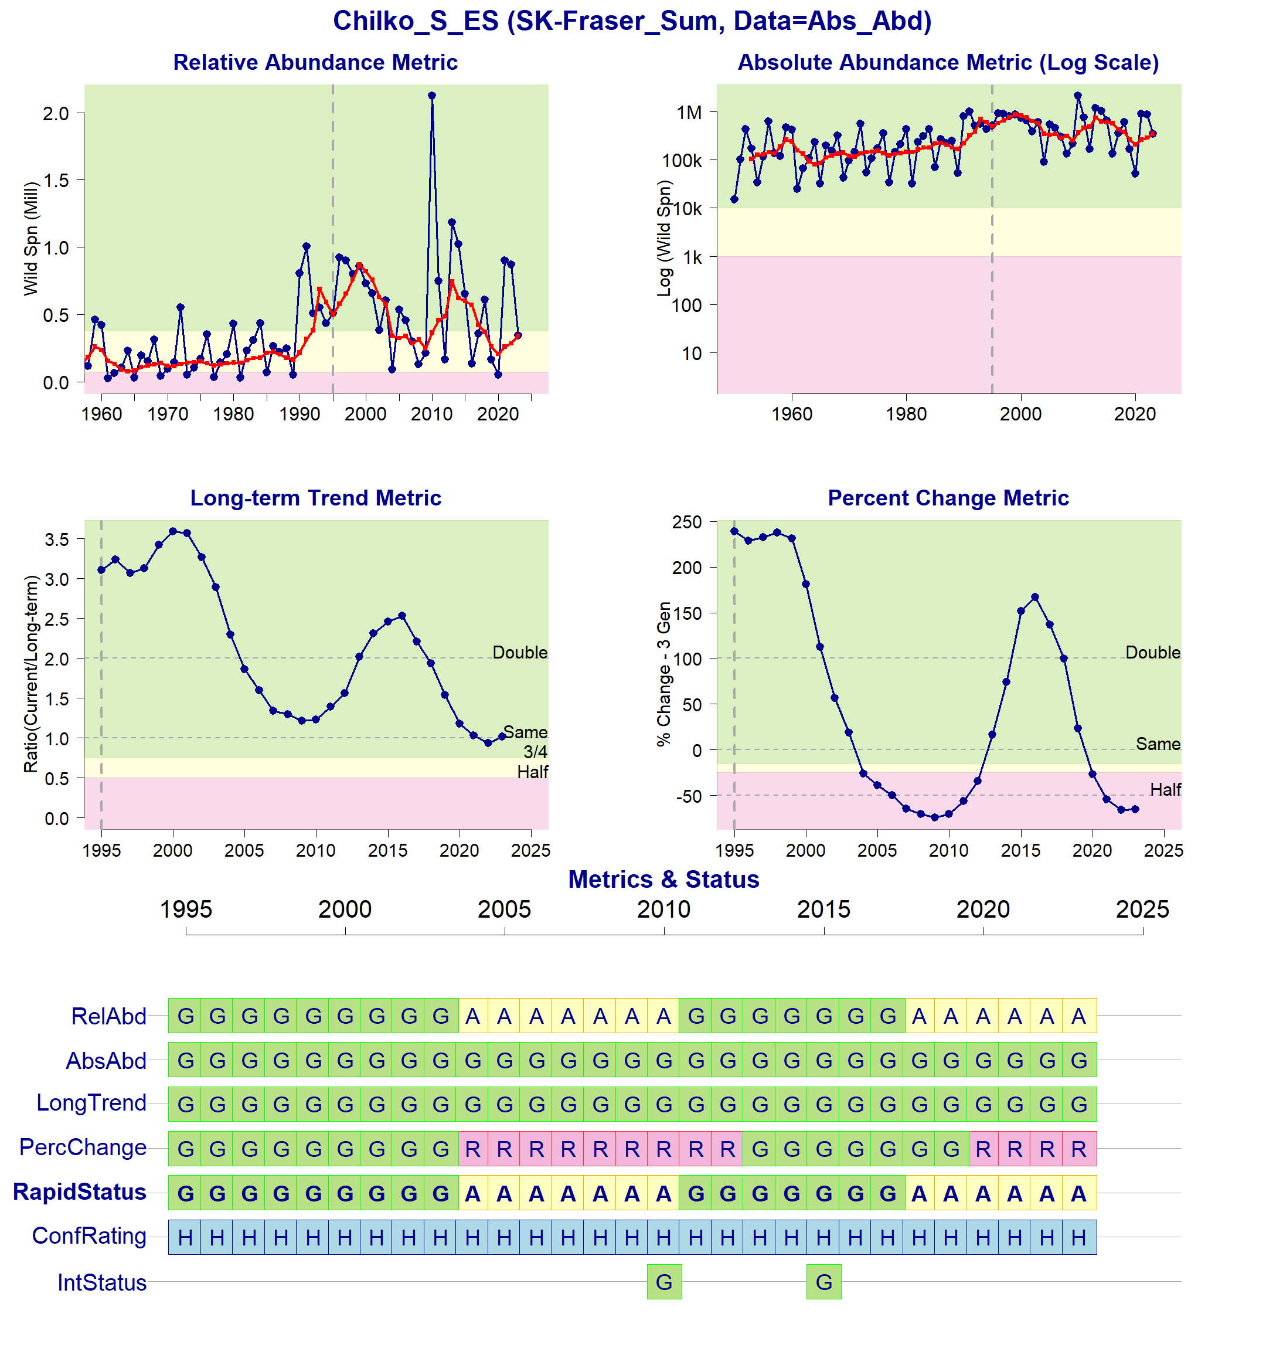Figure 1: Metrics and Status for Chilko-S-ES (SEL-06-03). Panels on top show the four standard WSP metrics, calculated based on the available time series of spawner abundances. Bottom panel summarizes the status for each individual metric and shows the resulting WSP rapid status for the CU with a confidence rating. If integrated WSP status assessments have been completed for this CU, they are shown on the last row (IntStatus). Note that metric benchmarks may differ from algorithm thresholds, since thresholds approximate the status determination process from past WSP integrated status assessments (see Figure 2).
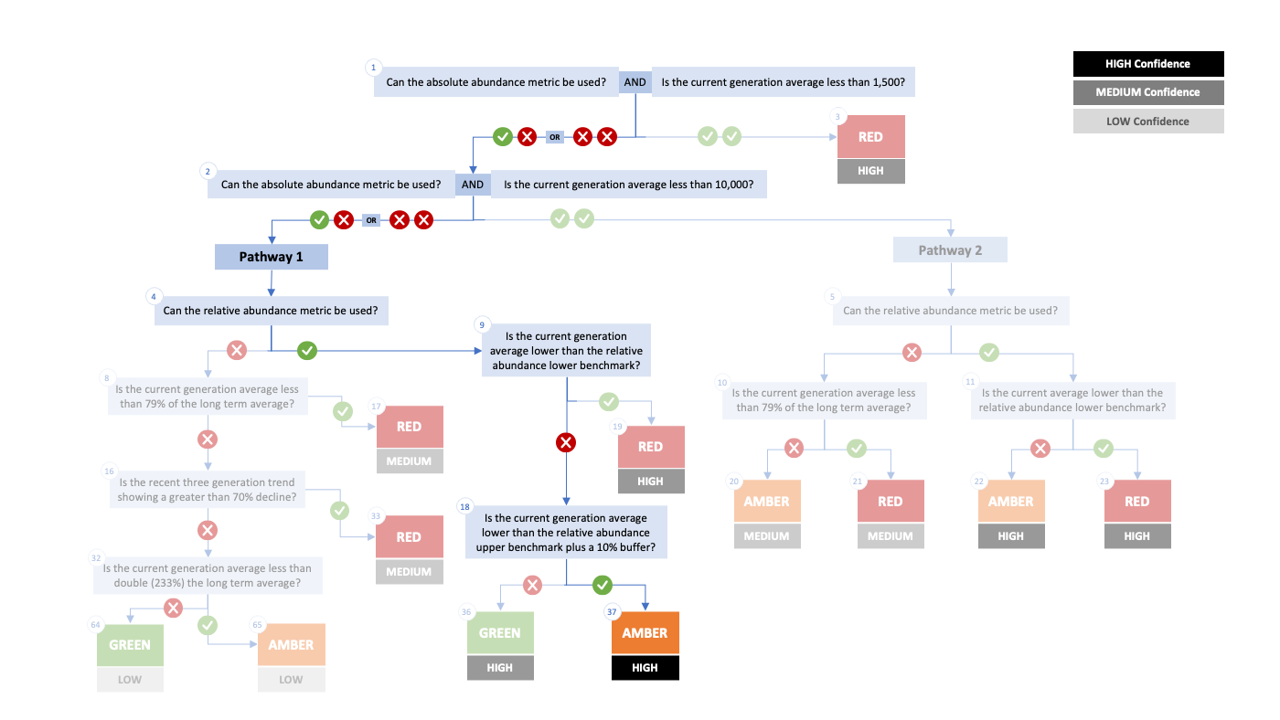Figure 2. Algorithm pathway taken to assess status for the Chilko-S-ES (SEL-06-03) in 2023. The recent generational average falls above the absolute abundance upper (10,000) threshold (node 1-2) but below the relative abundance upper (nodes 4, 9, and 18). Status for this CU is therefore designated as Amber with High confidence at Node 37.
Table 4: Decision tree path given data and metric values for the Chilko-S-ES (SEL-06-03) in 2023; this aligns with Figure 2 above. For each node, the algorithm decision is made by comparing the CUs current metric value to the metric threshold and answering Yes or No, running through sequential nodes and decisions until the final WSP rapid status for that CU and year is reached.
Node | Metric | Metric Threshold | CU’s Current Value | Decision
1 | Absolute Abundance | <1,500 | 343,202 | YES, NO
2 | Absolute Abundance | <10,000 | 343,202 | YES, NO
4 | Relative Abundance | Available? | - | YES
9 | Relative Abundance | <72,471 | 343,202 | NO
18 | Relative Abundance | <417,253 | 343,202 | YES
37 | FINAL STATUS NODE | - | - | AMBER, HIGH

SEL-06-07 Francois-Fraser-S
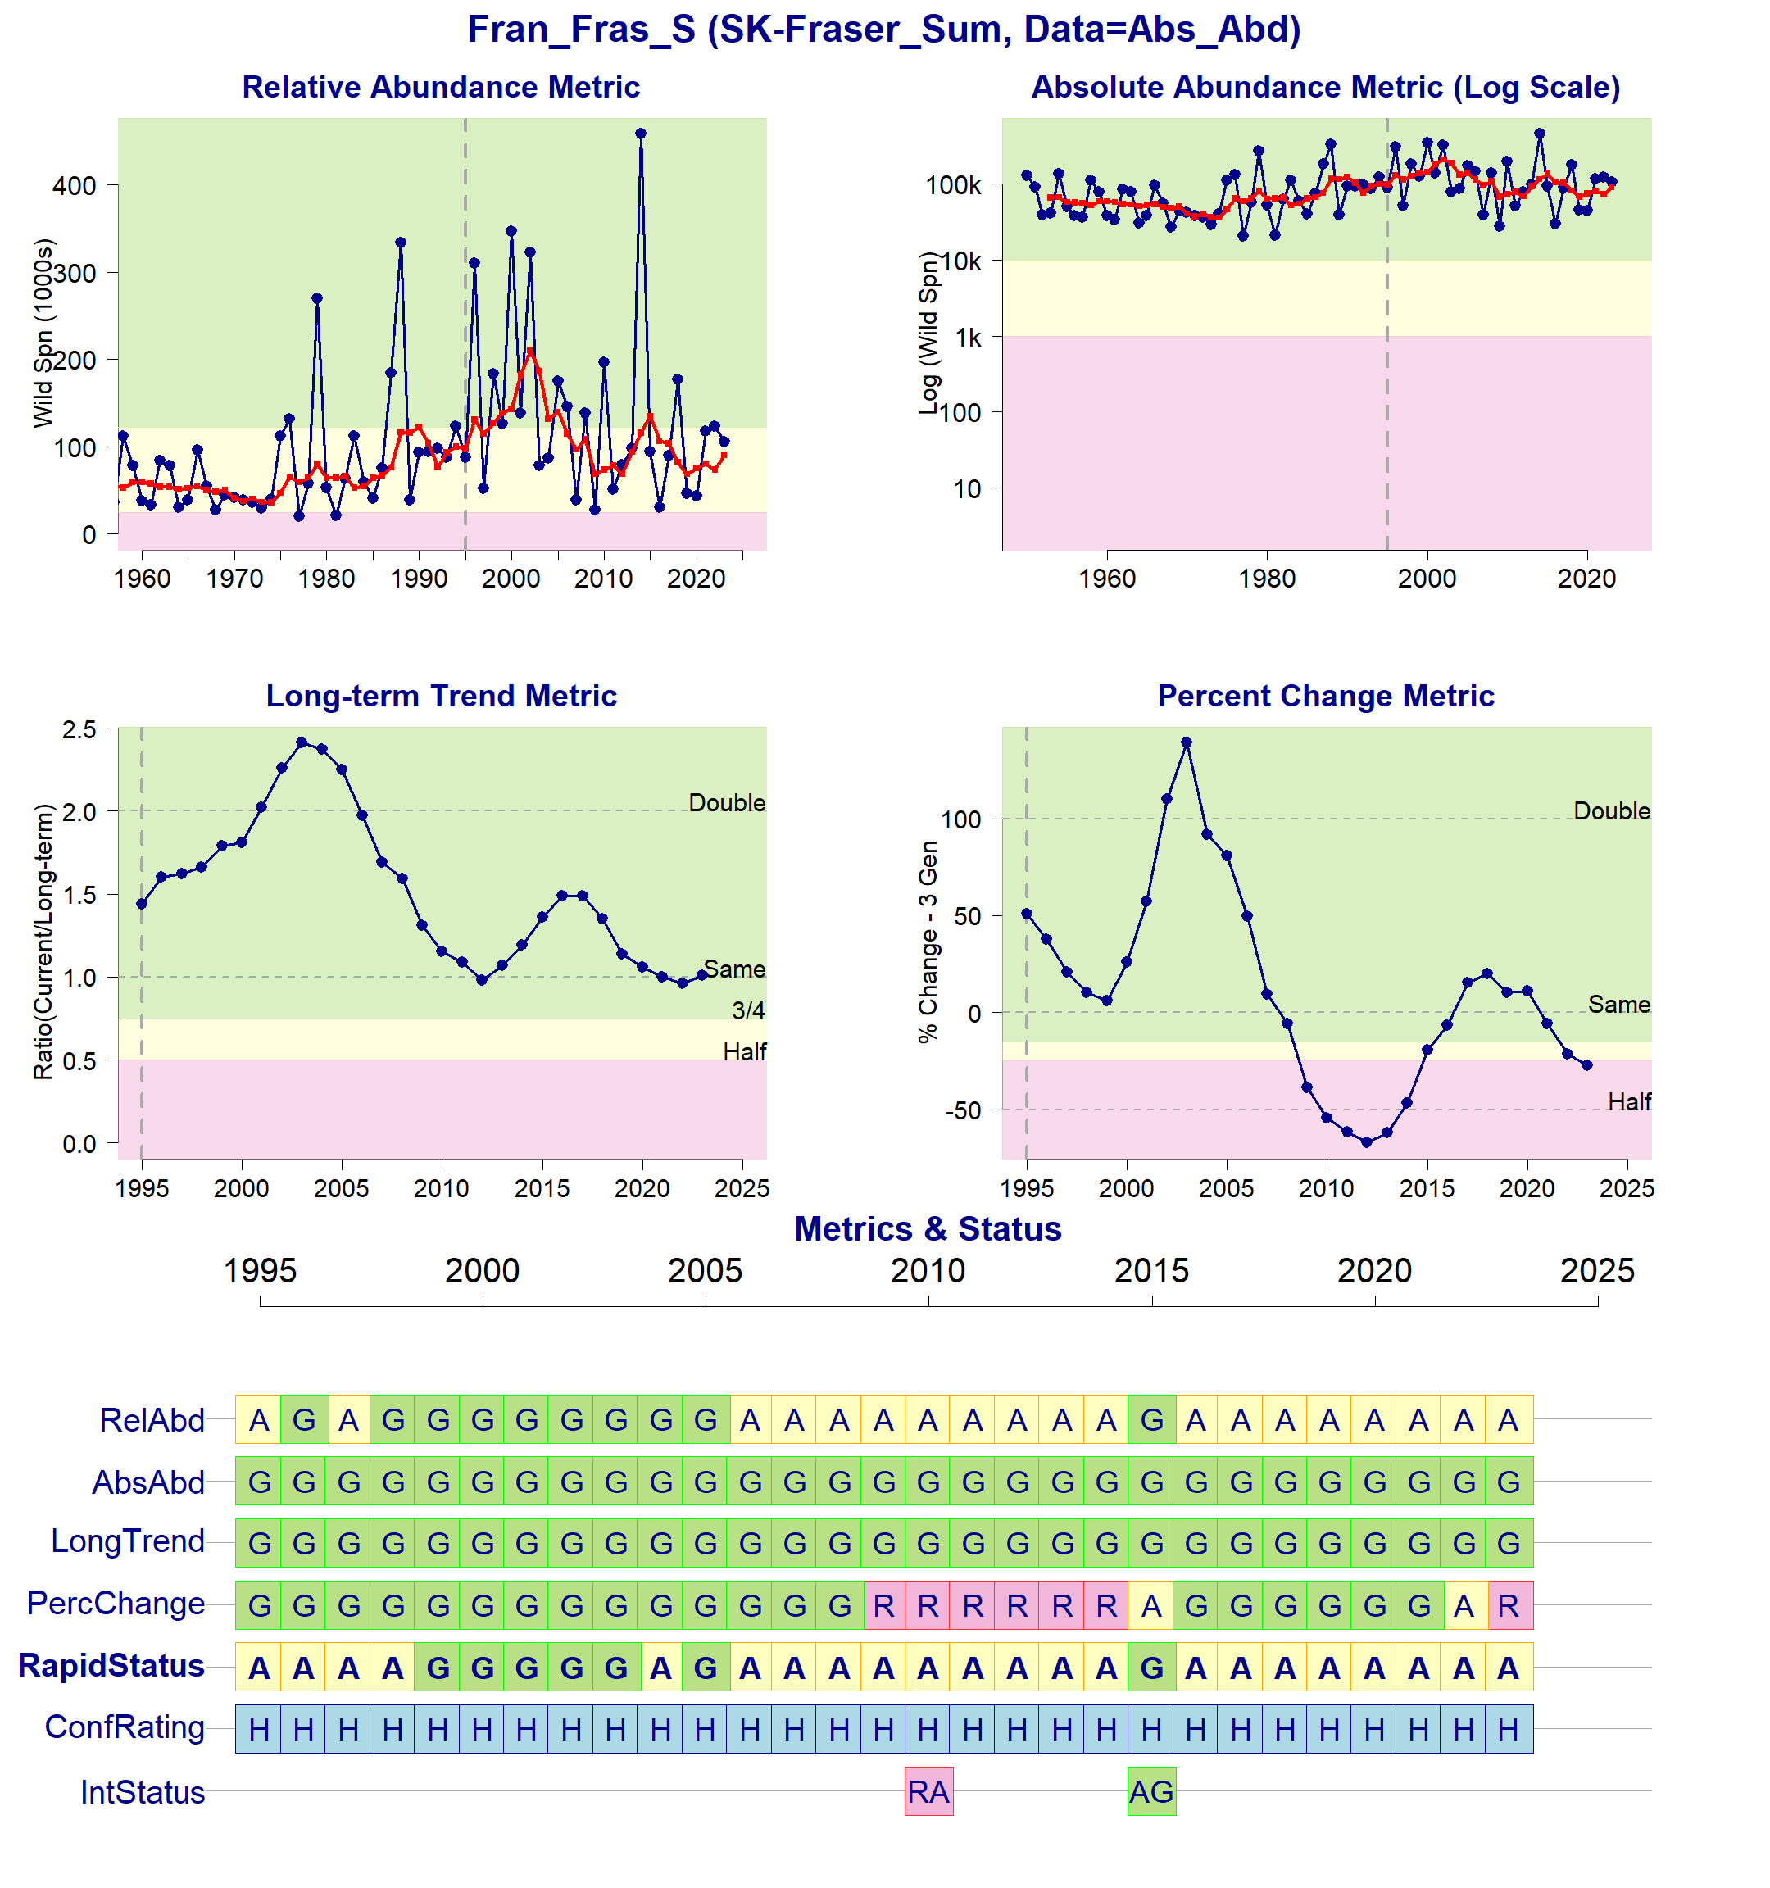Figure 3: Metrics and Status for Francois-Fraser (SEL-06-07). Panels on top show the four standard WSP metrics, calculated based on the available time series of spawner abundances. Bottom panel summarizes the status for each individual metric and shows the resulting WSP rapid status for the CU with a confidence rating. If integrated WSP status assessments have been completed for this CU, they are shown on the last row (IntStatus). Note that metric benchmarks may differ from algorithm thresholds, since thresholds approximate the status determination process from past WSP integrated status assessments (see Figure 4).
Figure 4. Algorithm pathway taken to assess status for the Francois-Fraser (SEL-06-07) in 2023. The recent generational average falls above the absolute abundance upper (10,000) threshold (node 1-2) but below the relative abundance upper (nodes 4, 9, and 18). Status for this CU is therefore designated as Amber with High confidence at Node 37.
Table 5: Decision tree path given data and metric values for the Francois-Fraser (SEL-06-07) in 2023; this aligns with Figure 5 above. For each node, the algorithm decision is made by comparing the CUs current metric value to the metric threshold and answering Yes or No, running through sequential nodes and decisions until the final WSP rapid status for that CU and year is reached.
Node | Metric | Metric Threshold | CU’s Current Value | Decision
1 | Absolute Abundance | <1,500 | 90,401 | YES, NO
2 | Absolute Abundance | <10,000 | 90,401 | YES, NO
4 | Relative Abundance | Available? | - | YES
9 | Relative Abundance | <24,256 | 90,401 | NO
18 | Relative Abundance | <134,873 | 90,401 | YES
37 | FINAL STATUS NODE | - | - | AMBER, HIGH

SEL-06-10 Quesnel-S
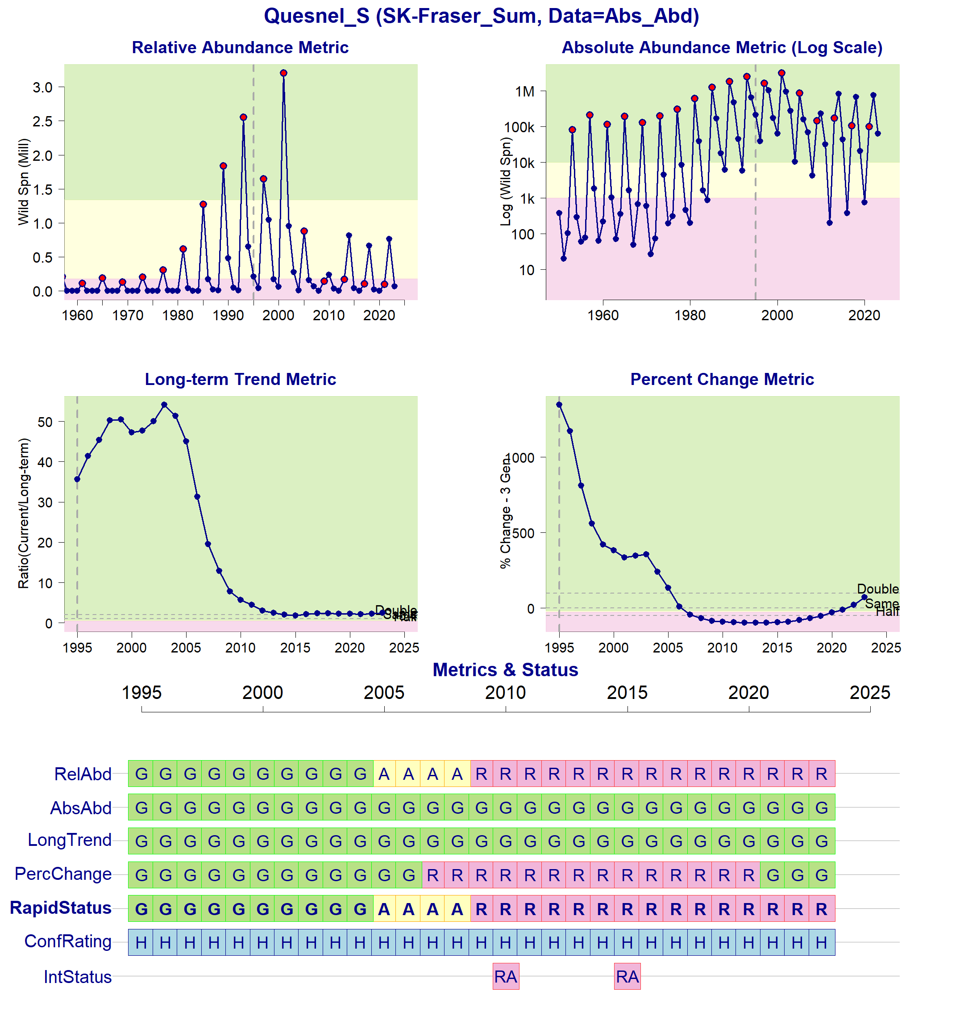Figure 5: Metrics and Status for Quesnel-S (SEL-06-10). Panels on top show the four standard WSP metrics, calculated based on the available time series of spawner abundances. Bottom panel summarizes the status for each individual metric and shows the resulting WSP rapid status for the CU with a confidence rating. If integrated WSP status assessments have been completed for this CU, they are shown on the last row (IntStatus). Note that metric benchmarks may differ from algorithm thresholds, since thresholds approximate the status determination process from past WSP integrated status assessments (see Figure 6).
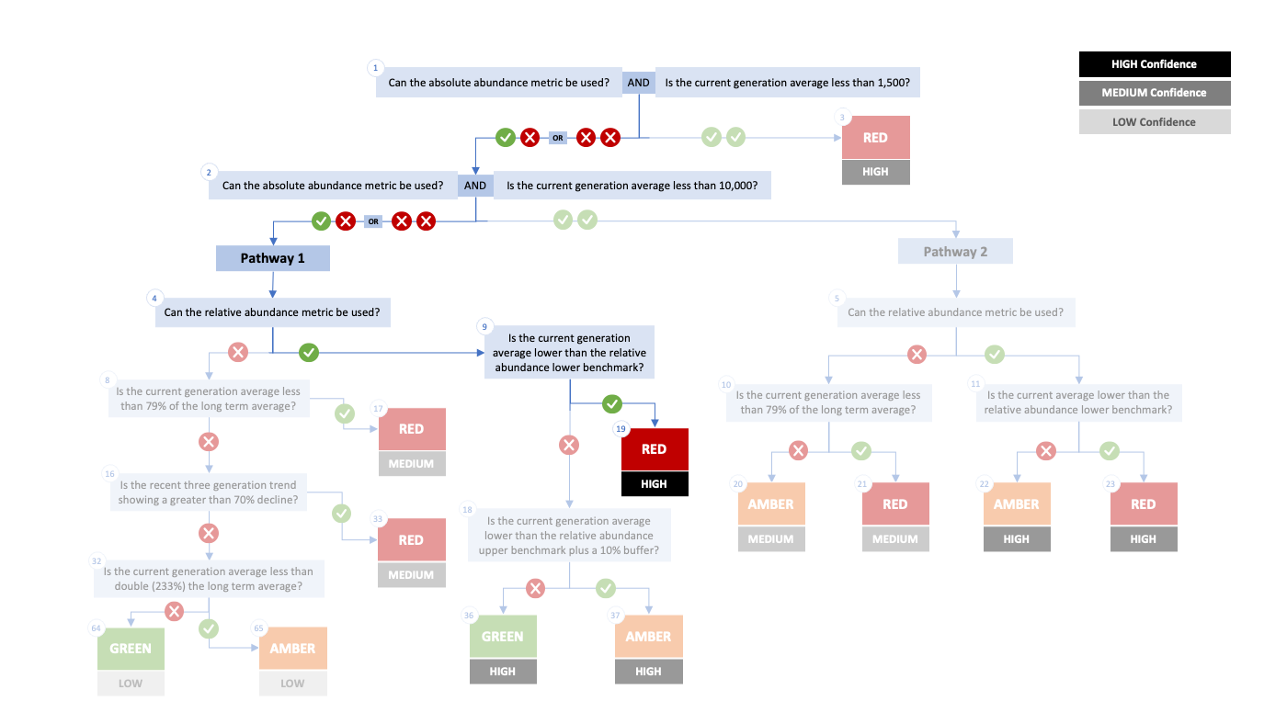Figure 6. Algorithm pathway taken to assess status for the Quesnel-S (SEL-06-10) in 2023. The recent generational average falls above the absolute abundance upper (10,000) threshold (node 1-2) but below the relative abundance upper (nodes 4 and 9). Status for this CU is therefore designated as Red with High confidence at Node 19.
Table 6: Decision tree path given data and metric values for the Quesnel-S (SEL-06-10) in 2023; this aligns with Figure 2 above. For each node, the algorithm decision is made by comparing the CUs current metric value to the metric threshold and answering Yes or No, running through sequential nodes and decisions until the final WSP rapid status for that CU and year is reached.
Node | Metric | Metric Threshold | CU’s Current Value | Decision
1 | Absolute Abundance | <1,500 | 43,693 | YES, NO
2 | Absolute Abundance | <10,000 | 43,693 | YES, NO
4 | Relative Abundance | Available? | - | YES
9 | Relative Abundance | <180,491 | 100,566 | YES
19 | FINAL STATUS NODE | - | - | RED, HIGH

SEL-06-13 Takla-Trembleur-Stuart-S
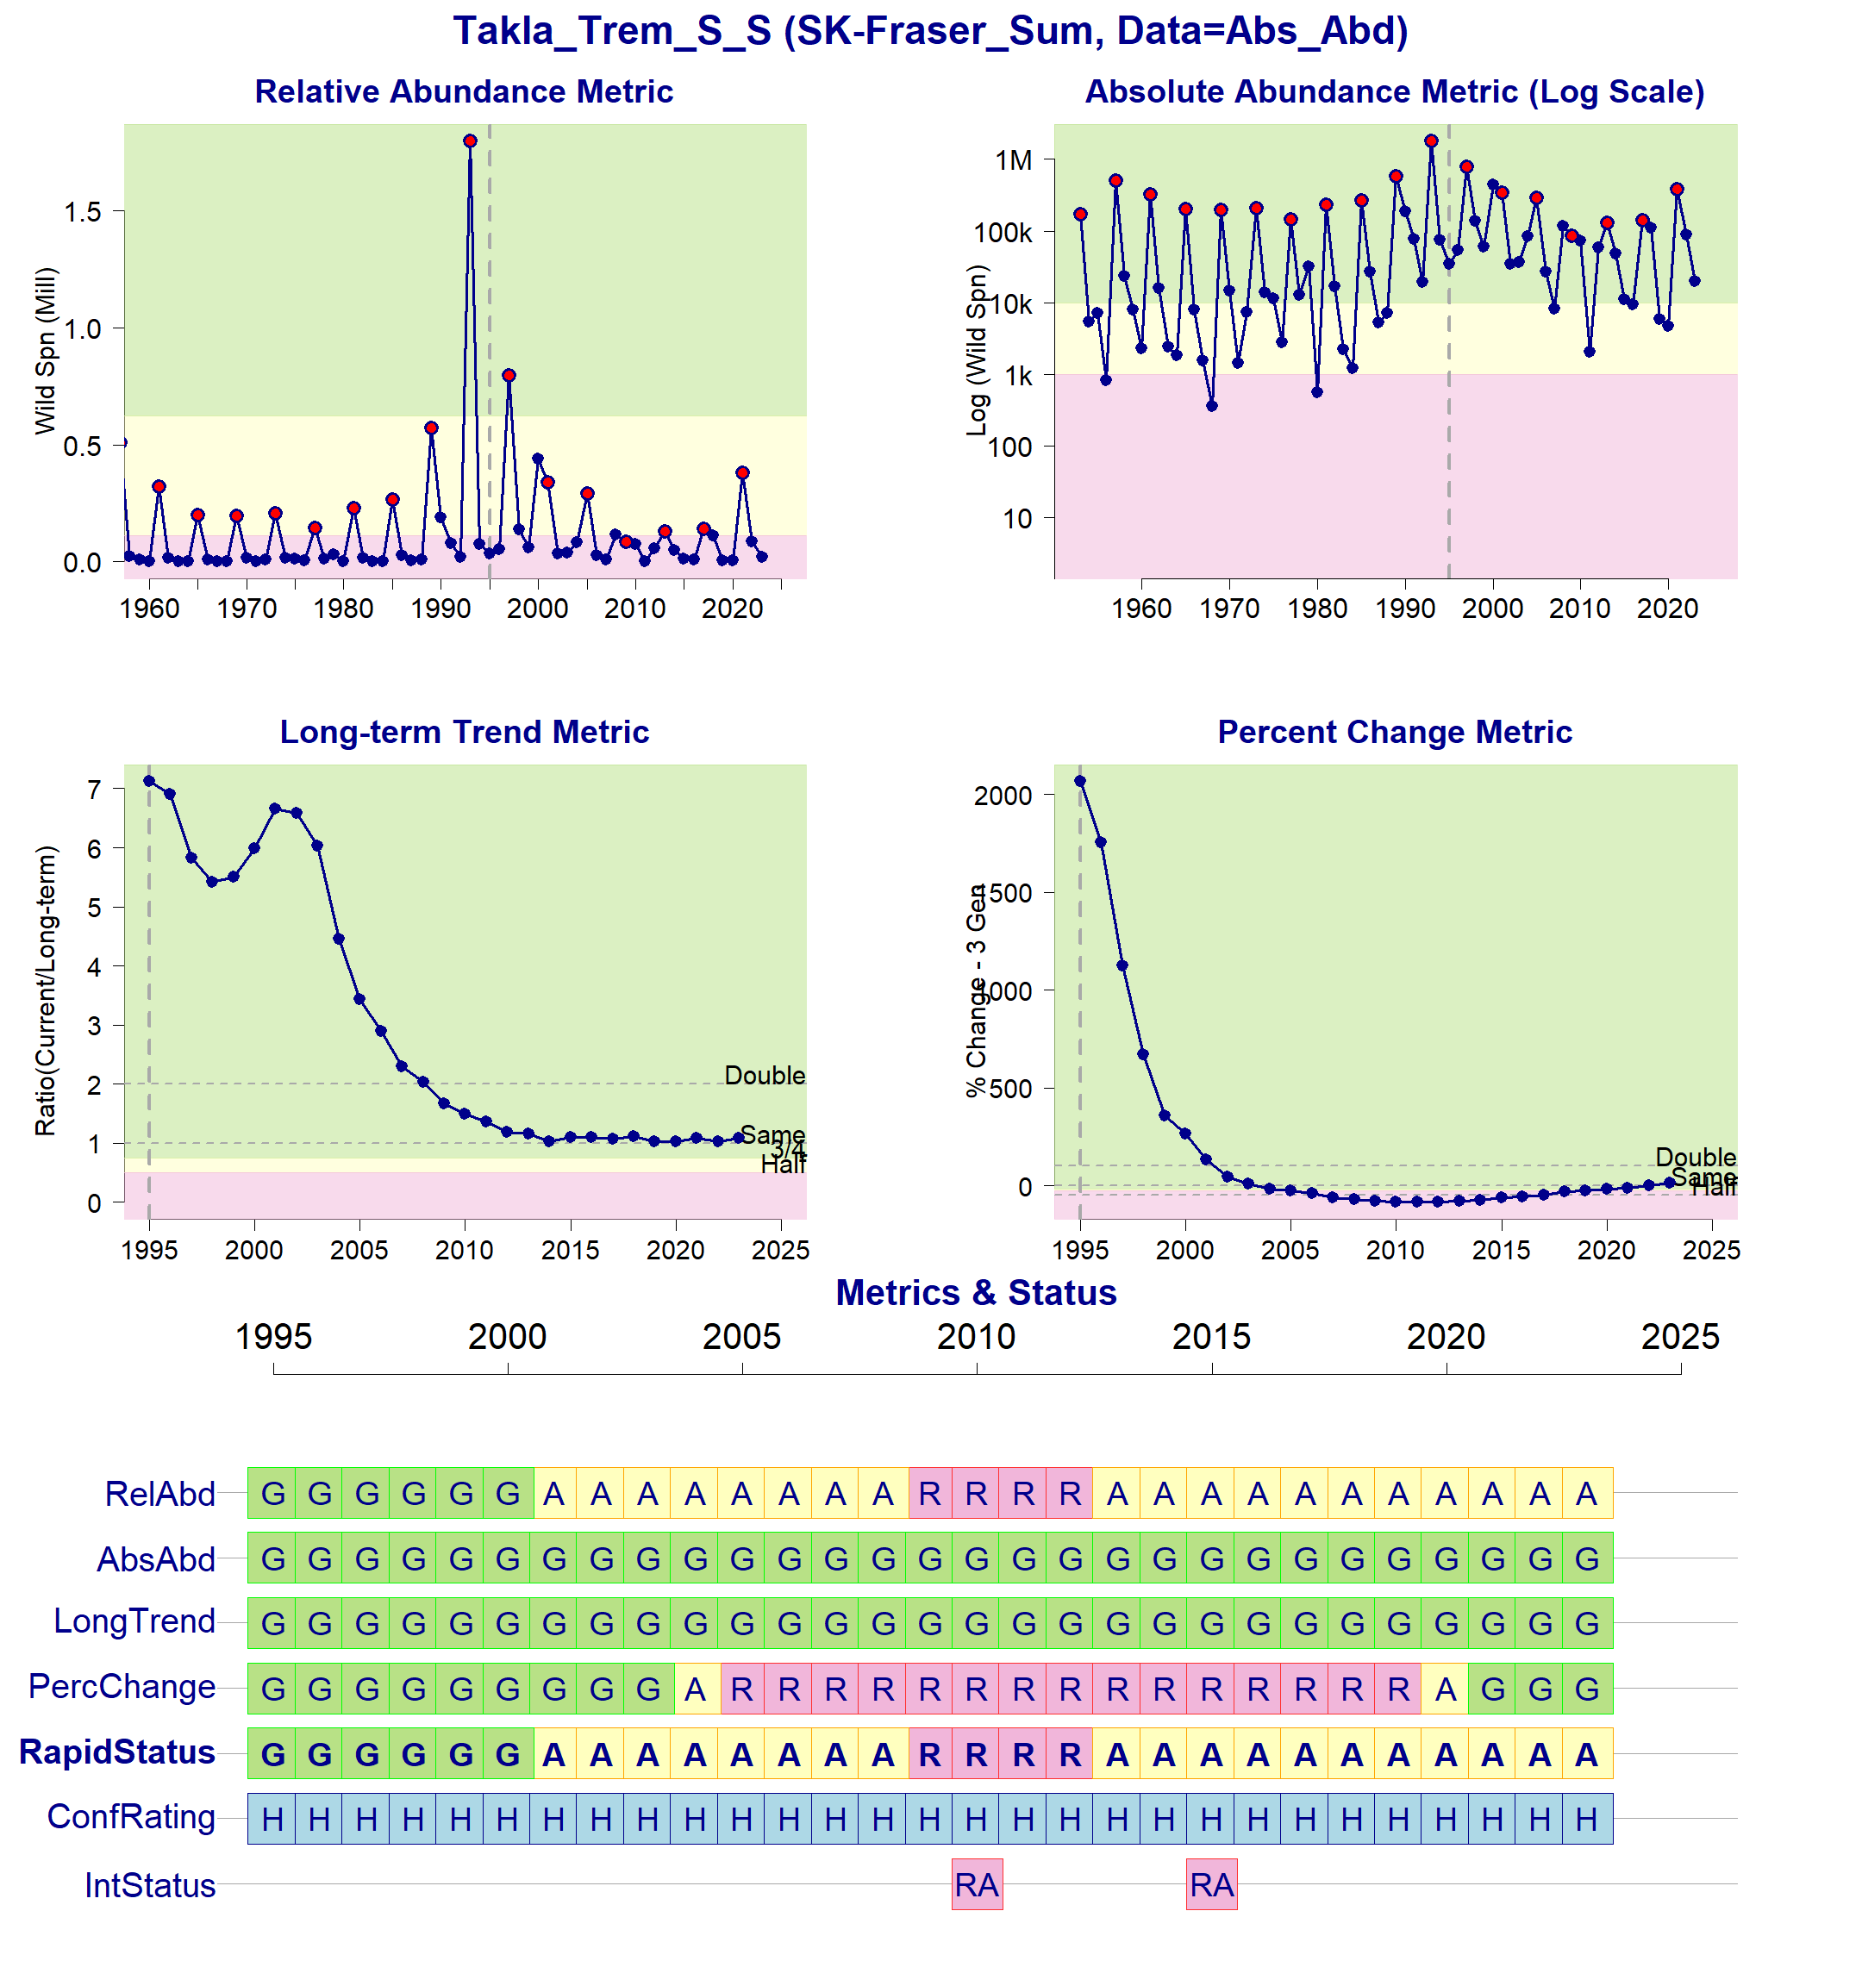Figure 7: Metrics and Status for Takla-Trembleur-Stuart-S (SEL-06-13). Panels on top show the four standard WSP metrics, calculated based on the available time series of spawner abundances. Bottom panel summarizes the status for each individual metric and shows the resulting WSP rapid status for the CU with a confidence rating. If integrated WSP status assessments have been completed for this CU, they are shown on the last row (IntStatus). Note that metric benchmarks may differ from algorithm thresholds, since thresholds approximate the status determination process from past WSP integrated status assessments (see Figure 8).
Figure 8. Algorithm pathway taken to assess status for the Takla-Trembleur-Stuart-S (SEL-06-13) in 2023. The recent generational average falls above the absolute abundance upper (10,000) threshold (node 1-2) but below the relative abundance upper (nodes 4, 9, and 18). Status for this CU is therefore designated as Amber with High confidence at Node 37.
Table 7: Decision tree path given data and metric values for the Takla-Trembleur-Stuart-S (SEL-06-13) in 2023; this aligns with Figure 2 above. For each node, the algorithm decision is made by comparing the CUs current metric value to the metric threshold and answering Yes or No, running through sequential nodes and decisions until the final WSP rapid status for that CU and year is reached.
Node | Metric | Metric Threshold | CU’s Current Value | Decision
1 | Absolute Abundance | <1,500 | 41,797 | YES, NO
2 | Absolute Abundance | <10,000 | 41,797 | YES, NO
4 | Relative Abundance | Available? | - | YES
9 | Relative Abundance | <112,600 | 379,351 | NO
18 | Relative Abundance | <684,887 | 379,351 | YES
37 | FINAL STATUS NODE | - | - | AMBER, HIGH

SEL-10-01 Kamloops-ES
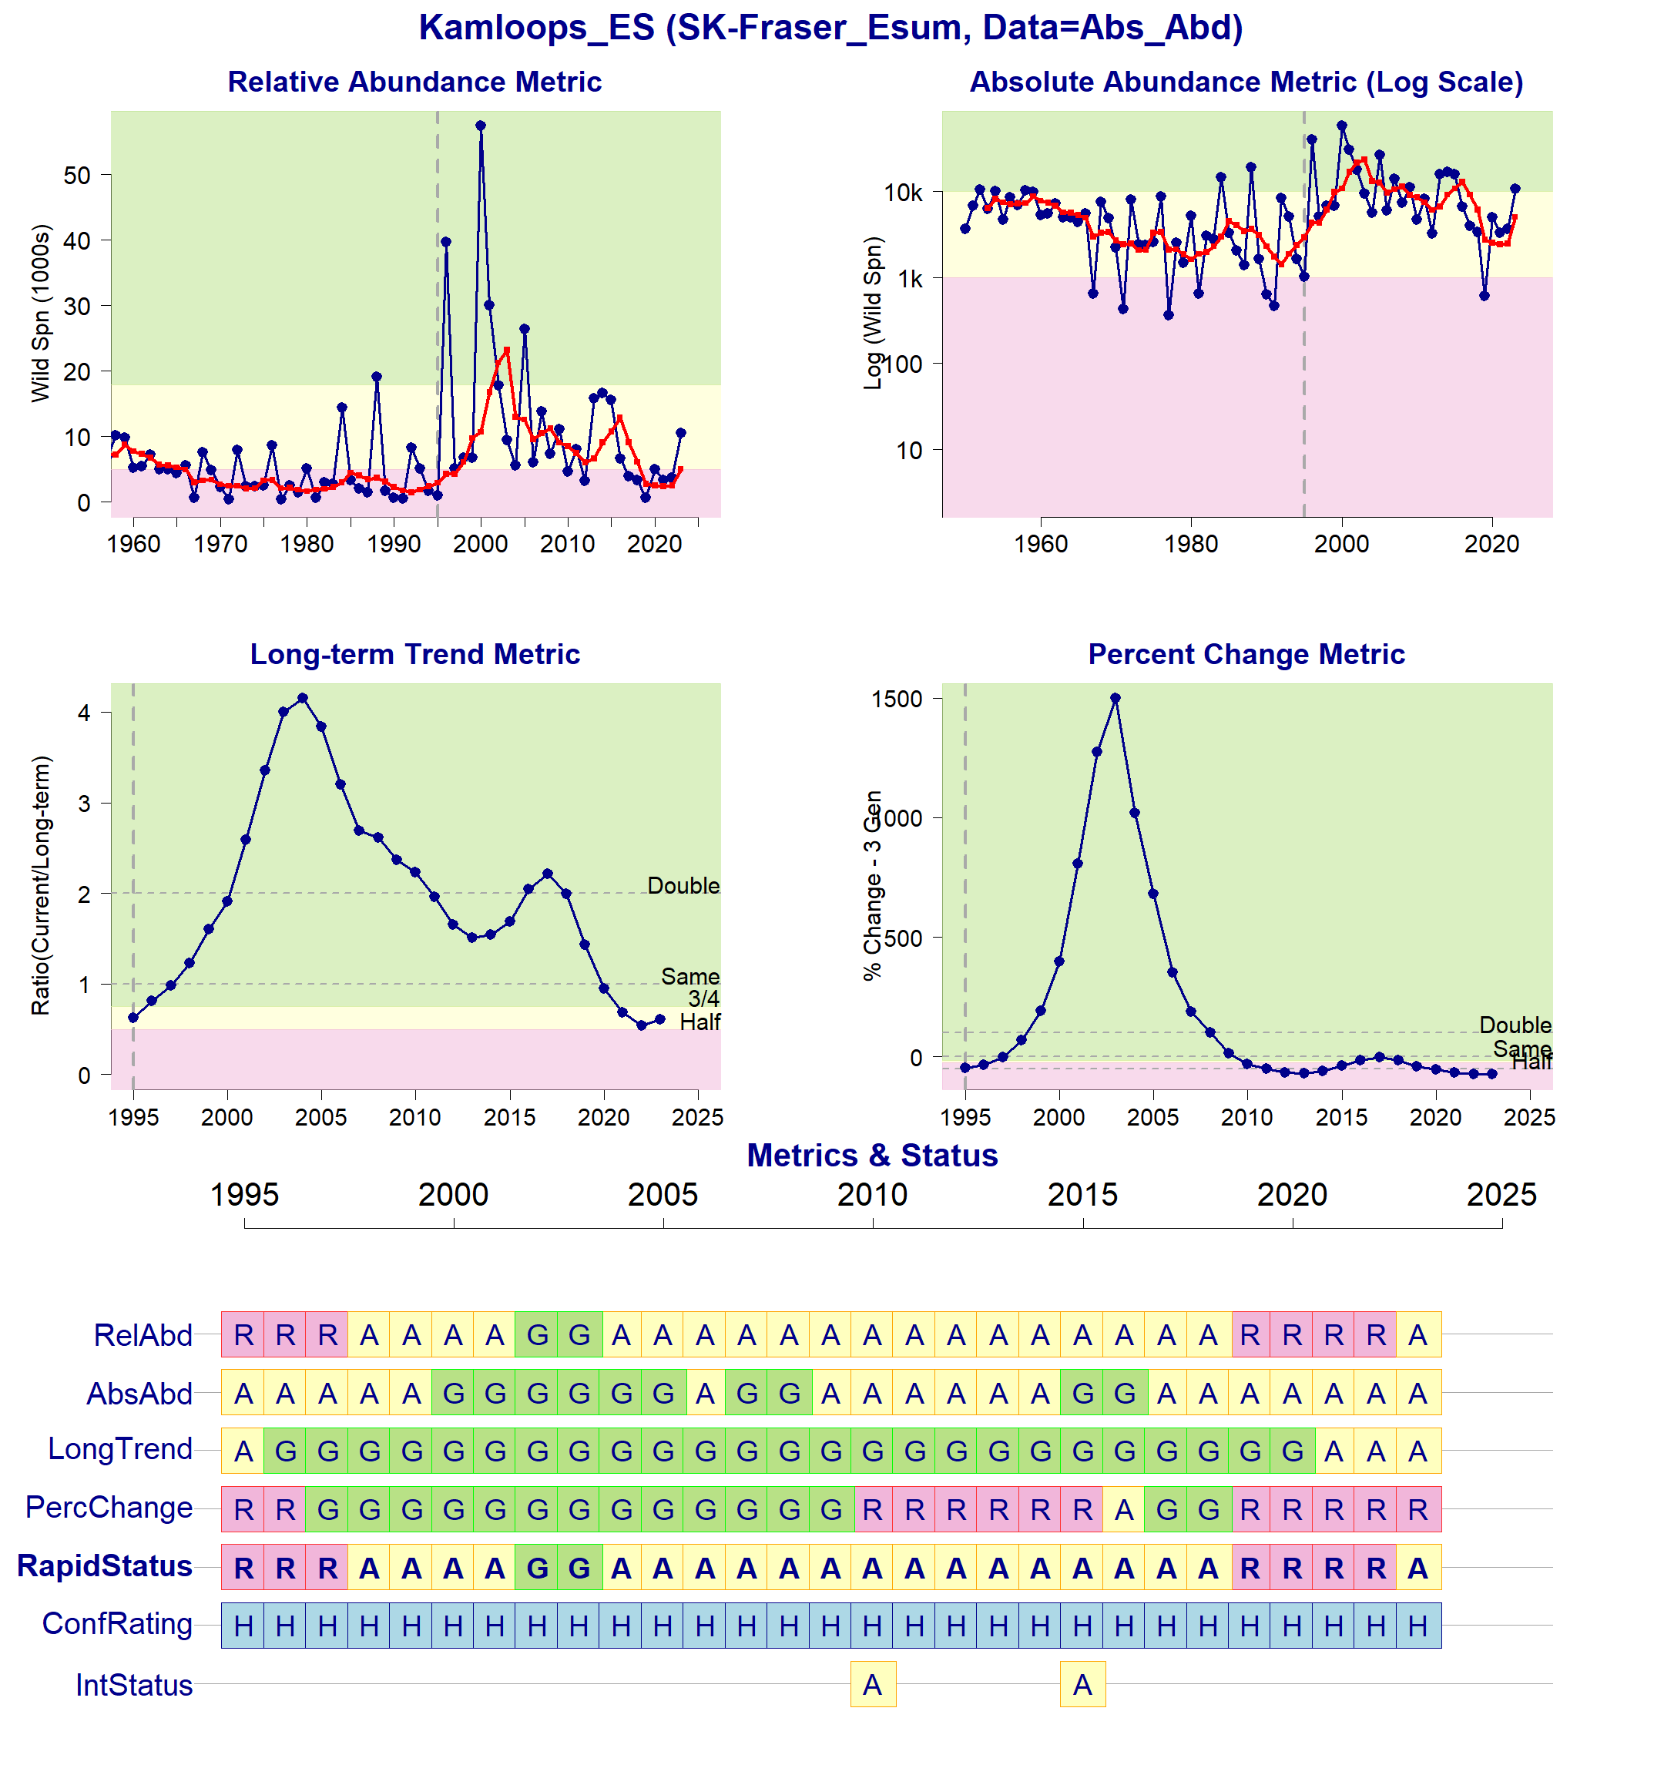Figure 9: Metrics and Status for Kamloops-ES (SEL-10-01). Panels on top show the four standard WSP metrics, calculated based on the available time series of spawner abundances. Bottom panel summarizes the status for each individual metric and shows the resulting WSP rapid status for the CU with a confidence rating. If integrated WSP status assessments have been completed for this CU, they are shown on the last row (IntStatus). Note that metric benchmarks may differ from algorithm thresholds, since thresholds approximate the status determination process from past WSP integrated status assessments (see Figure 10).
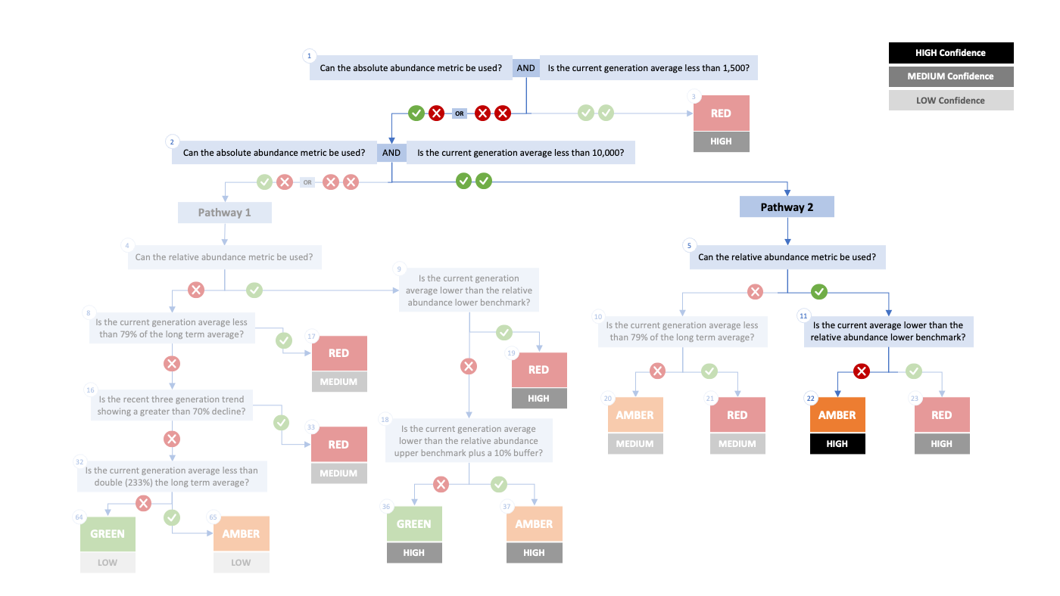Figure 10. Algorithm pathway taken to assess status for the Kamloops-ES (SEL-10-01) in 2023. The recent generational average falls below the absolute abundance upper (10,000) threshold (node 1-2) and below the relative abundance upper (nodes 5 and 11). Status for this CU is therefore designated as Amber with High confidence at Node 22.
Table 8: Decision tree path given data and metric values for the Kamloops-ES (SEL-10-01) in 2023; this aligns with Figure 2 above. For each node, the algorithm decision is made by comparing the CUs current metric value to the metric threshold and answering Yes or No, running through sequential nodes and decisions until the final WSP rapid status for that CU and year is reached.
Node | Metric | Metric Threshold | CU’s Current Value | Decision
1 | Absolute Abundance | <1,500 | 5,007 | YES, NO
2 | Absolute Abundance | <10,000 | 5,007 | YES, YES
5 | Relative Abundance | Available? | - | YES
11 | Relative Abundance | <4,958 | 5,007 | NO
22 | FINAL STATUS NODE | - | - | AMBER, HIGH

SER-02 Widgeon-RT
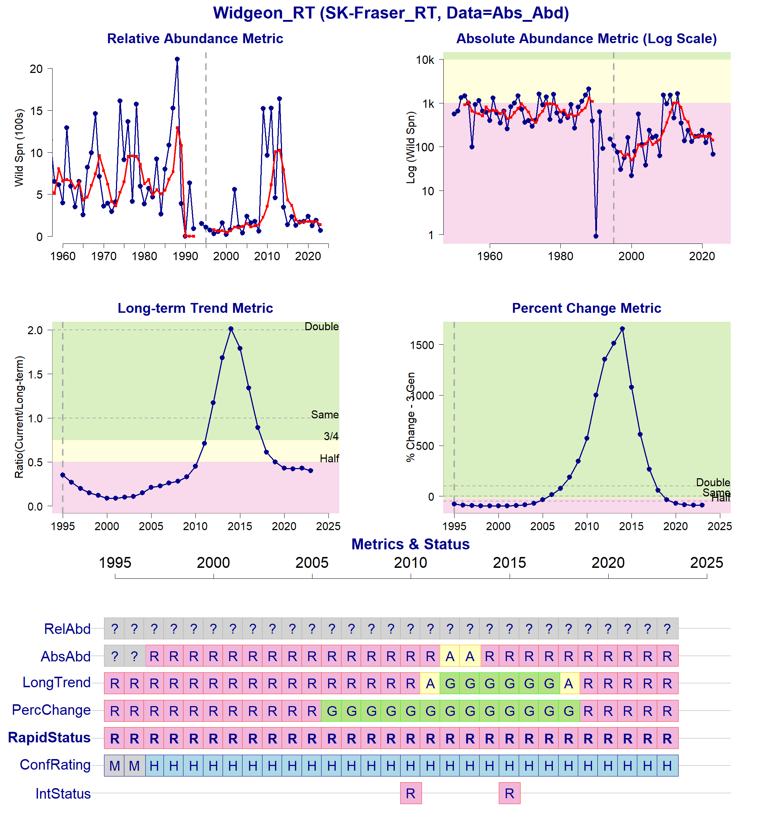Figure 11: Metrics and Status for Widgeon-RT (SER-02). Panels on top show the four standard WSP metrics, calculated based on the available time series of spawner abundances. There are no relative abundance benchmarks, so they cannot be indicated in the top left figure. Bottom panel summarizes the status for each individual metric and shows the resulting WSP rapid status for the CU with a confidence rating. If integrated WSP status assessments have been completed for this CU, they are shown on the last row (IntStatus). Note that metric benchmarks may differ from algorithm thresholds, since thresholds approximate the status determination process from past WSP integrated status assessments (see Figure 12).
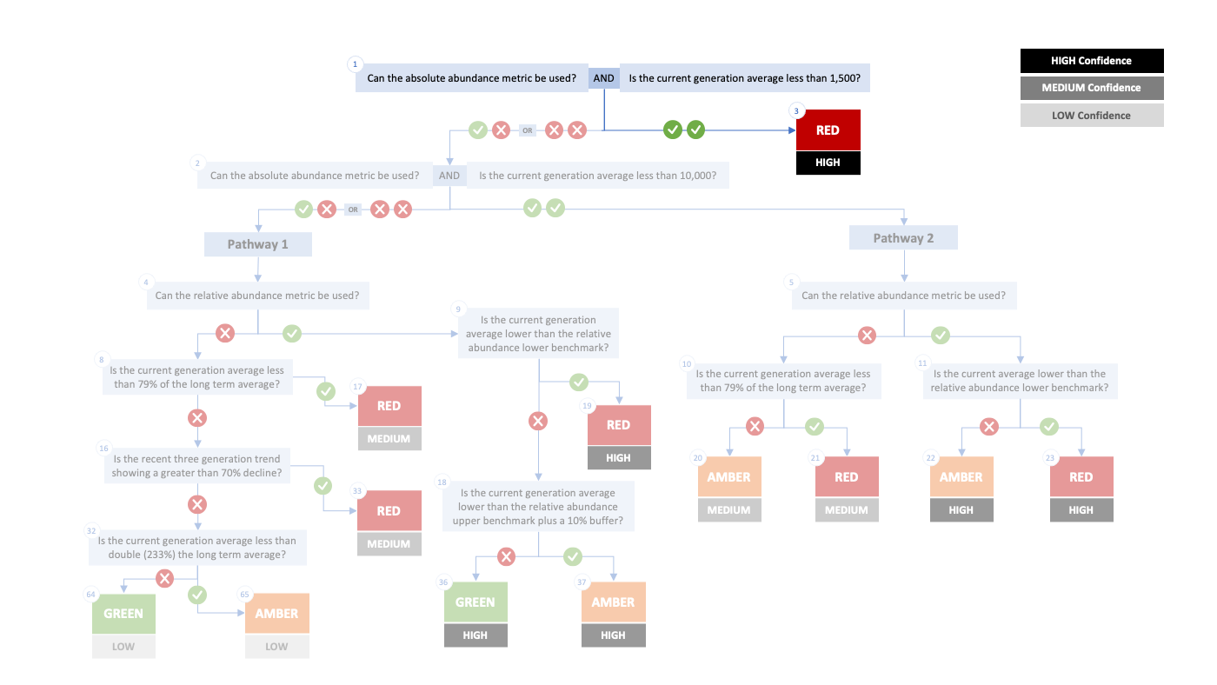Figure 12. Algorithm pathway taken to assess status for the Widgeon-RT (SER-02) in 2023. The recent generational average falls below the absolute abundance lower (1,500) threshold (node 1). Status for this CU is therefore designated as Red with High confidence at Node 3.
Table 9: Decision tree path given data and metric values for the Widgeon-RT (SER-02) in 2023; this aligns with Figure 2 above. For each node, the algorithm decision is made by comparing the CUs current metric value to the metric threshold and answering Yes or No, running through sequential nodes and decisions until the final WSP rapid status for that CU and year is reached.
Node | Metric | Metric Threshold | CU’s Current Value | Decision
1 | Absolute Abundance | <1,500 | 140 | YES, YES
3 | FINAL STATUS NODE |  |  | RED, HIGH

SER-03 Harrison-R
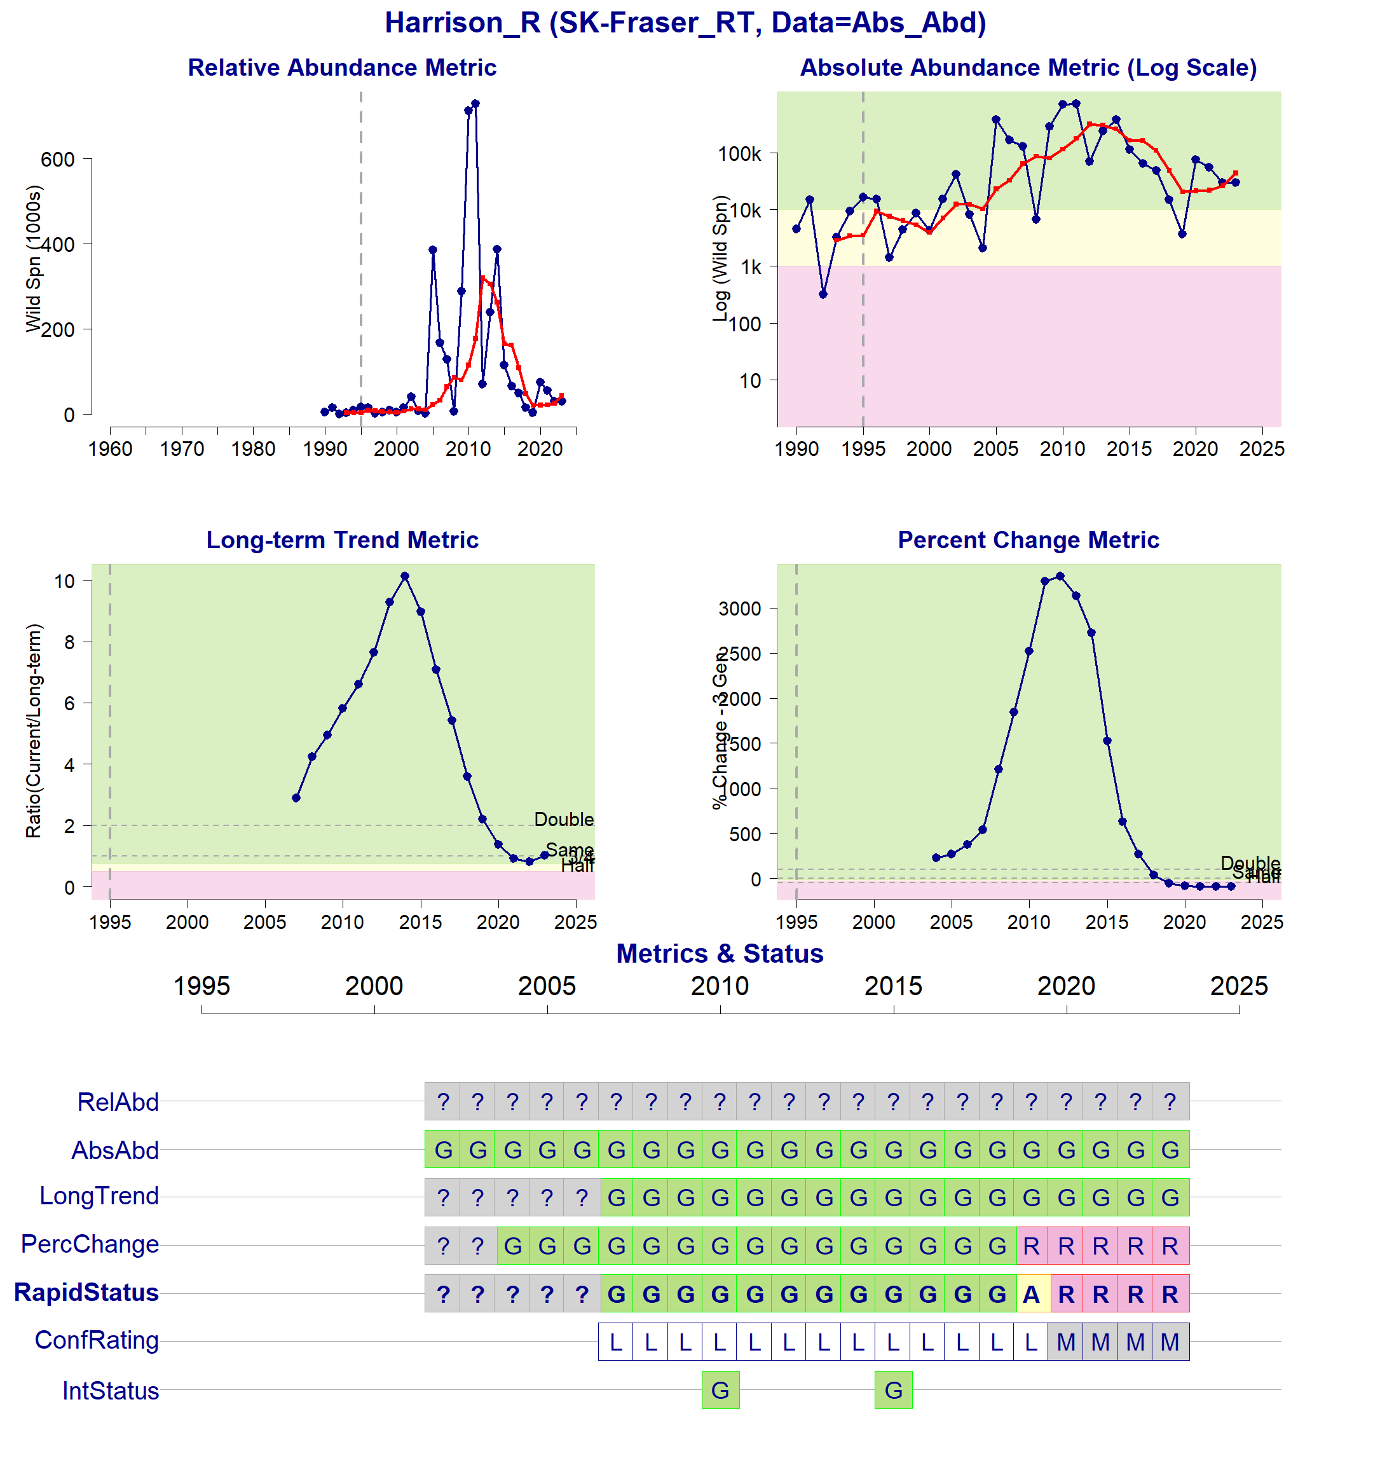Figure 13: Metrics and Status for Harrison-R (SER-03). Panels on top show the four standard WSP metrics, calculated based on the available time series of spawner abundances. There are no relative abundance benchmarks, so they cannot be indicated in the top left figure. Bottom panel summarizes the status for each individual metric and shows the resulting WSP rapid status for the CU with a confidence rating. If integrated WSP status assessments have been completed for this CU, they are shown on the last row (IntStatus). Note that metric benchmarks may differ from algorithm thresholds, since thresholds approximate the status determination process from past WSP integrated status assessments (see Figure 14).
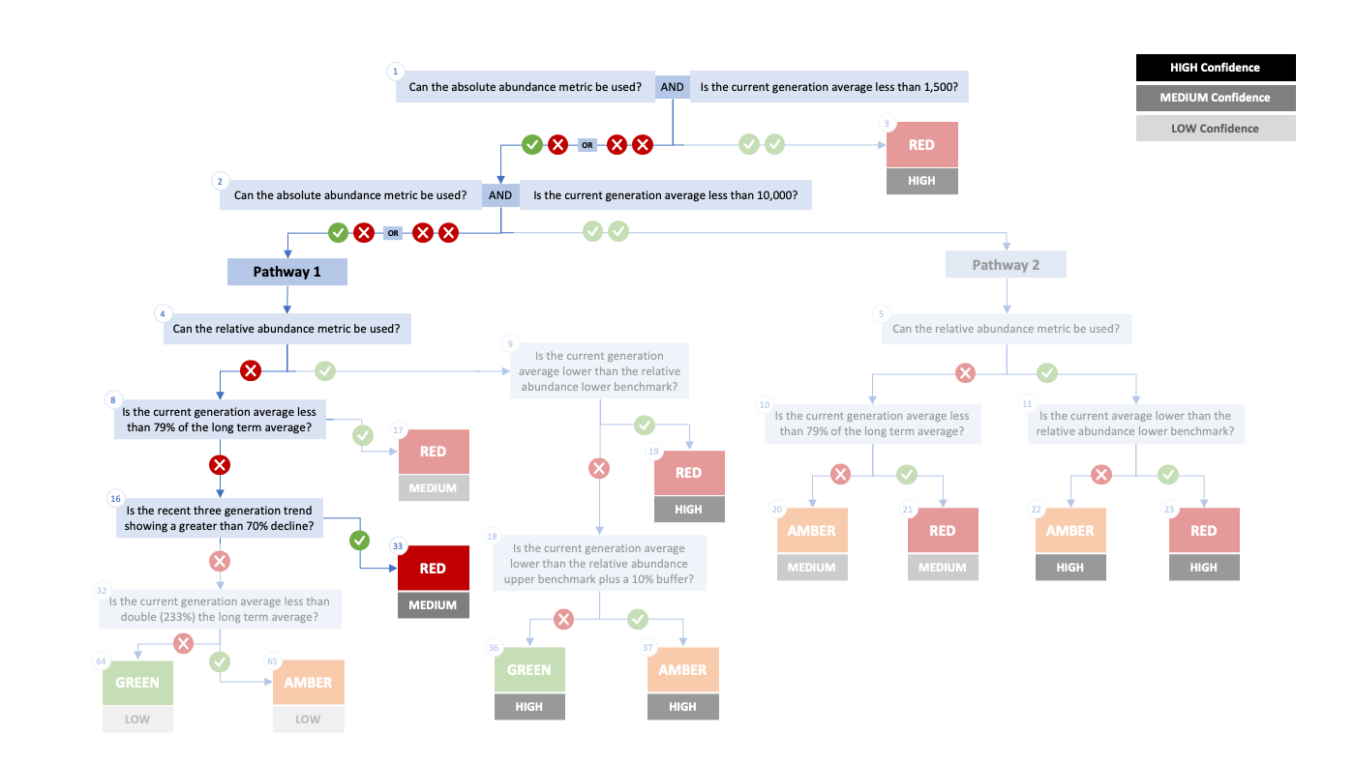Figure 14. Algorithm pathway taken to assess status for the Harrison-R (SER-03) in 2023. The recent generational average falls above the absolute abundance upper (10,000) threshold (node 1-2) but since there are no relative abundance thresholds, the long term trend and percent change metrics are used (nodes 4, 8, and 16). Status for this CU is therefore designated as Red with Medium confidence at Node 33.
Table 10: Decision tree path given data and metric values for the Harrison-R (SER-03) in 2023; this aligns with Figure 2 above. For each node, the algorithm decision is made by comparing the CUs current metric value to the metric threshold and answering Yes or No, running through sequential nodes and decisions until the final WSP rapid status for that CU and year is reached.
Node | Metric | Metric Threshold | CU’s Current Value | Decision
1 | Absolute Abundance | <1,500 | 43,850 | YES, NO
2 | Absolute Abundance | <10,000 | 43,850 | YES, NO
4 | Relative Abundance | Available? | - | NO
8 | Long-Term Trend | <79% | 81% | NO
16 | Percent-Change | <-70% | -94.5% | YES
33 | FINAL STATUS NODE | - | - | RED, MEDIUM

Cited and other Key References
Doutaz, D., Huang, A.-M., Decker, S., Vivian, T. 2023. Recovery Potential Assessment for Fraser River Sockeye Salmon (Oncorhynchus nerka), Nine Designatable Units Part 2: Biology, Habitat, Threats, Mitigations and Allowable Harm - Elements 1-11, 14, 16-18, 22. DFO Can. Sci. Advis. Sec. Res. Doc. 2023/003. xiii + 250 p.
DFO. 2005. Canada’s Policy for Conservation of Wild Pacific Salmon. Fisheries and Oceans Canada, Vancouver, B.C., pp. vi+ 49.
DFO. 2009. A Fishery Decision-Making Framework Incorporating the Precautionary Approach.
DFO. 2022. Methodologies and guidelines for defining limit reference points for Pacific Salmon. CSAS SAR 2022/030. pp. 16.
DFO. 2023. Science advice on guidance for limit reference points under the Fish Stocks provisions. DFO Can. Sci. Advis. Sec. Sci. Advis. Rep. 2023/009.
DFO 2024. Rapid status approximations for Pacific salmon derived from integrated status assessments under DFO’s Wild Salmon Policy. CSAS Sci. Resp. 2024/004.
Grant, S.C.H., MacDonald, B.L., Cone, T.E., Holt, C.A., Cass, A., Porszt, E.J., Hume, J.M.B., and Pon, L.B. 2011. Evaluation of Uncertainty in Fraser Sockeye (Oncorhynchus nerka) Wild Salmon Policy Status using Abundance and Trends in Abundance Metrics. Can. Sci. Advis. Sec. Res. Doc. 2011/087. Viii + 183
Grant, S.C.H. & G. Pestal. 2013. Integrated Biological Status Assessments Under the Wild Salmon Policy Using Standardized Metrics and Expert Judgement: Fraser River Sockeye Salmon (Oncorhynchus nerka) Case Studies. Can. Sci. Advis. Sec. Res. Doc. 2012/106. v + 132 p.
Grant, S.C.H., MacDonald, B.L., and Winston, M.L. 2019. State of the Canadian Pacific salmon: responses to changing climate and habitats. Can. Tech. Rep. Fish. Aquat. Sci. 3332: ix + 50 pp. Available from http://www.dfo-mpo.gc.ca/species-especes/publications/salmon-saumon/state-etat-2019/abstract-resume/index-eng.html
Grant, S.C.H., Holt, C., Pestal, G., MacDonald, B.L. 2020. The 2017 Fraser Sockeye Salmon (Oncorhynchus nerka) Integrated Biological Status Re-Assessments Under the Wild Salmon Policy Using Standardized Metrics and Expert Judgment. Can. Sci. Advis. Sec. Res. Doc. 2020/035. vii + 211 p.
Holt, C.A., Cass, A., Holtby, B., and Riddell, B. 2009. Indicators of status and benchmarks for Conservation Units in Canada’s Wild Salmon Policy. Can. Sci. Advis. Sec. Res. Doc. 2009/058: viii + 74.
Holt, C.A., Holt, K., Wor, C., Warkentin, L., Connors, B., Grant, S.C.H., and Huang, A.-M. 2023a. Guidelines for Defining Limit Reference Points for Pacific Salmon Stock Management Units. Can. Sci. Adv. Sec. Res. Doc. 2023/009: iv + 66.
Holt, K., Holt, C.A., Warkentin, L., Wor, C., Davis, B., Arbeider, M., Bokvist, J., Crowley, S., Grant, S.C.H., Luedke, W., McHugh, D., Picco, C., and Will, P. Van. 2023b. Case Study Applications of LRP Estimation Methods to Pacific Salmon Stock Management Units. Can. Sci. Advis. Sec. Res. Doc. 2023/010: iv + 129.
Holt, C.A., and Irvine, J.R. 2013. Distinguishing benchmarks of biological status from management reference points: a case study on Pacific salmon in Canada. Environ. Conserv. 40 (4): 345–355. doi:https://doi.org/10.1017/S0376892913000209
Holtby, B.L., and Ciruna, K.A. 2007. Conservation units for Pacific salmon under the Wild Salmon Policy. Can. Sci. Advis. Sec. Res. Doc. 2007/070: viii + 350 pp. Available from http://www.dfo-mpo.gc.ca/csas-sccs/publications/resdocs-docrech/2007/2007_070-eng.htm
Huang, A-M., Pestal, G., Guthrie, I. 2021. Recovery Potential Assessment for Fraser River Sockeye Salmon (Oncorhynchus nerka) – Nine Designatable Units: Probability of Achieving Recovery Targets - Elements 12, 13, 15, 19-22. DFO Can. Sci. Advis. Sec. Res. Doc. 2021/043. x + 96.
Pestal, G., MacDonald, B.L., Grant, S.C.H., and Holt, C.A. 2023. State of the Salmon: rapid status assessment approach for Pacific salmon under Canada’s Wild Salmon Policy. Can. Tech. Rep. Fish. Aquat. Sci. 3570: xiv + 200 p.
Pestal, G., MacDonald, B.L., Grant, S.C.H., and Carr-Harris, C. 2024. State of the Salmon: Wild Salmon Policy rapid status approach for Fraser, Skeena, and Nass sockeye, Fraser pink and chum, Interior Fraser Coho, and southern BC Chinook salmon. Can. Tech. Rep. Fish. Aquat. Sci. (in Prep).

Appendix A: WSP rapid status approach details

The decision tree sequence is as follows (see Figure A1; Table A1, A2):
- The first question is whether or not a CU has a current absolute abundance value, and if so, whether or not this value falls below the lower threshold of 1,500 (which adds a buffer to Committee on the Status of Endangered Wildlife in Canada (COSEWIC) Criterion D1 for small population size of 1,000). If the answer to this question is Yes, then the CU is assigned Red (node 3), with High confidence.
- If the answer to the first question is No, then the second question is whether or not the CU has a current absolute abundance value, and if so, whether or not the current abundance is below the upper threshold of 10,000, which is COSEWIC's Criterion C upper benchmark. This second question splits the decision nodes into two Pathways: Pathway 1 (No to this question) and Pathway 2 (Yes to this question).
  - Pathway 1: is where a CU either does not have a current absolute abundance value, or has these data, and it falls above the upper threshold for this metric. This pathway is split with the question: can this CU be assessed with a relative abundance metric. If the answer is Yes, a Red (nodes 19), Amber (nodes 37) or Green (node 36) WSP rapid status is assigned, with High confidence, depending on where the current abundance value falls relative to this metric’s lower and upper thresholds. If the answer is NO, then comparisons are made between the CU’s current abundances and percent change to thresholds for these metrics, which assign a Red with Medium confidence, or Green or Amber with Low confidence status.
  - Pathway 2: is where a CU has absolute abundance data, and these abundances fall between the lower and upper thresholds. In this pathway, absolute abundances restrict WSP rapid statuses to only Amber or Red. This pathway is split with the question: can this CU be assessed with a relative abundance metric. If the answer is Yes, an Amber (node 22) with Medium confidence, or Red (node 23) with High confidence, is assigned, depending on whether the CU’s current abundance value falls above the relative abundance metric lower threshold or below. If the CU cannot be assessed with a relative abundance metric, then it is compared to the lower threshold of the Long-Term trend metric and assigned Amber (node 20) with Medium confidence if above, or Red (node 21) with Medium confidence if below.

Table A1. Biological status zones under the Wild Salmon Policy (WSP).

Status |  | Definition
 | Red | Poor status CU facing an imminent threat of extinction [revised definition, given alignment with COSEWIC Endangered statuses]
 | Amber | “While a CU in the Amber zone should be at low risk of loss, there will be a degree of lost production. Still, this situation may results when CUs share risk factors with other, more productive units”. Aligns with COSEWIC Threatened and Special Concern statuses.
 | Green | “identif[ies] whether harvest are greater than the level expected to provide on an average annual basis, the maximum annual catch for a CU, given existing conditions…there would not be a high probability of losing the CU”. Aligns with COSEWIC Not at Risk statuses.
 | DD | Data deficient. CUs have been designated as DD if there is no data available, or if the available data is insufficient for calculating status metrics (after quality control).

Table A2. WSP rapid status Learning Tree 3 status assignments by node (see Figure 1). This table presents the decisions in Learning Tree 3 that led to Red or Amber or Green status assignments; status outcomes depend on the pathway and decisions made. The final node that corresponds to the status assignment is presented below (see Figure 1).
Node | Status | Rule
Node3 | Red | Data Type is Absolute Abundance AND Absolute Abundance < 1,500
Node17 | Red | Data Type is Relative Index OR Absolute Abundance ≥ 1,500;  then Data Type is Relative Index OR Absolute Abundance ≥ 10,000;  then no Relative Abundance lower benchmark; then Long Term Trend < 79%
Node19 | Red | Data Type is Relative Index OR Absolute Abundance ≥ 1,500;  then Data Type is Relative Index OR Absolute Abundance ≥ 10,000  then have Relative Abundance lower benchmark;  then Relative Abundance < Relative Abundance lower benchmark
Node20 | Amber | Data Type is Relative Index OR Absolute Abundance ≥ 1,500;  then Data Type is Absolute Abundance AND Absolute Abundance<10,000;  then no Relative Abundance lower benchmark; then Long Term Trend ≥ 79%
Node21 | Red | Data Type is Relative Index OR Absolute Abundance ≥ 1,500;  then Data Type is Absolute Abundance AND Absolute Abundance<10,000;  then no Relative Abundance lower benchmark; then Long Term Trend < 79%
Node22 | Amber | Data Type is Relative Index OR Absolute Abundance ≥ 1,500;  then Data Type is Absolute Abundance AND Absolute Abundance<10,000;  then have Relative Abundance lower benchmark;  then Relative Abundance ≥ Relative Abundance lower benchmark
Node23 | Red | Data Type is Relative Index OR Absolute Abundance ≥ 1,500;  then Data Type is Absolute Abundance AND Absolute Abundance<10,000;  then have Relative Abundance lower benchmark;  then Relative Abundance < Relative Abundance lower benchmark
Node33 | Red | Data Type is Relative Index OR Absolute Abundance ≥ 1,500;  then Data Type is Relative Index OR Absolute Abundance ≥ 10,000;  then no Relative Abundance lower benchmark;  then Long Term Trend ≥ 79%; then Percent Change < -70
Node36 | Green | Data Type is Relative Index OR Absolute Abundance ≥ 1,500;  then Data Type is Relative Index OR Absolute Abundance ≥ 10,000  then have Relative Abundance lower benchmark;  then Relative Abundance ≥ Relative Abundance lower benchmark;  then Relative Abundance ≥ Relative Abundance upper benchmark x 1.1
Node37 | Amber | Data Type is Relative Index OR Absolute Abundance ≥ 1,500;  then Data Type is Relative Index OR Absolute Abundance ≥ 10,000  then have Relative Abundance lower benchmark;  then Relative Abundance ≥ Relative Abundance lower benchmark;  then Relative Abundance < Relative Abundance upper benchmark x 1.1
Node64 | Green | Data Type is Relative Index OR Absolute Abundance ≥ 1,500;  then Data Type is Relative Index OR Absolute Abundance ≥ 10,000;  then no Relative Abundance lower benchmark;  then Long Term Trend ≥ 79%; then Percent Change < -70  then Long Term Trend ≥ 233
Node65 | Amber | Data Type is Relative Index OR Absolute Abundance ≥ 1,500;  then Data Type is Relative Index OR Absolute Abundance ≥ 10,000;  then no Relative Abundance lower benchmark;  then Long Term Trend ≥ 79%;  then Percent Change < -70  then Long Term Trend < 233

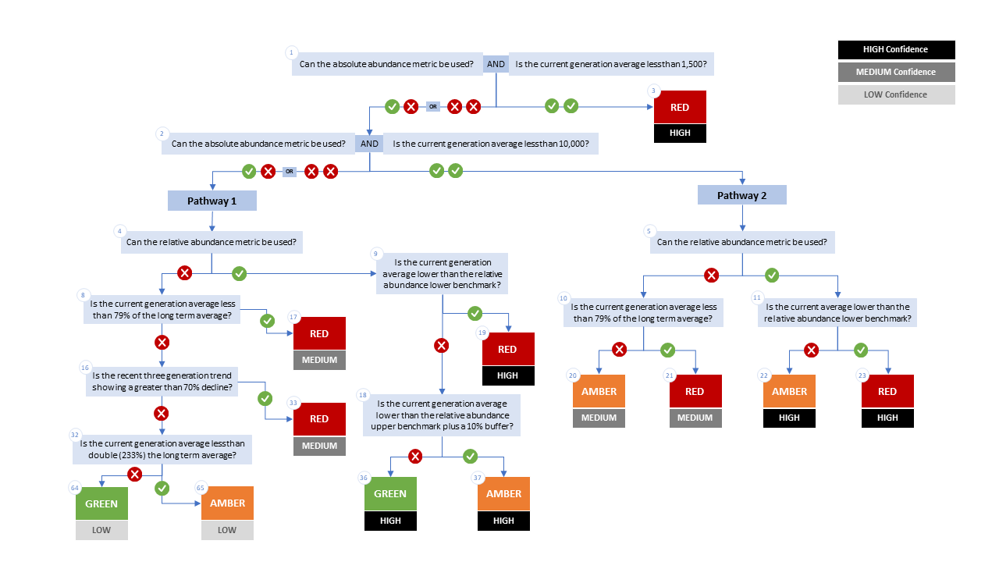

Figure A1. WSP rapid status decision tree (Table 2 includes written descriptions). To assess a CU, metric values are compared to thresholds presented at each decision point. Yes or No answers split each path of the decision tree, terminating at WSP rapid status assignments. The different splits are identified as nodes: 1 to 65. Pathway 1 is taken when the CU has no absolute abundance data, or these data exist, but fall above its upper threshold of 10,000. Pathway 2 is taken when the CU has absolute abundance data and these fall under its upper benchmark of 10,000.

Appendix B: Meeting History and Participants
Tables and summaries of meetings and participants, specifically participants who identified as a subject matter expert for one or more CUs.
Table B1. Meeting participants for the review of the 2022/23 Wild Salmon Policy Rapid Status Scanner for Fraser Pink, Chum and Sockeye. Meeting took place on January 8, 2025.
Kaitlyn Dionne | Fraser and Interior Stock Assessment, DFO
Michael Arbeider | Fraser and Interior Stock Assessment, DFO
Chuck Parken | Fraser and Interior Stock Assessment, DFO
Colin Bailey | Fraser and Interior Stock Assessment, DFO
Sue Grant | Science, DFO
Isabella Borea | Fraser and Interior Stock Assessment, DFO
Marissa Glavas | Fraser and Interior Stock Assessment, DFO
Scott Decker | Fraser and Interior Stock Assessment, DFO
Matthew Townsend | Fraser and Interior Stock Assessment, DFO
Kelsey Campbell | Upper Fraser Fisheries Commission
Pete Nicklin | Tsilqotin National Government
Elinor McGrath | Okanagan Nation Alliance
Chad Fuller | Okanagan Nation Alliance
Michelle Walsh | Secwepmec Fisheries Commission
Maxine Bruce | Lil’wat First Nation

Consensus: general agreement of group as a whole, or absence of evidence-based opposition to conclusions. Determined by the “weight of evidence” (scientific data, information, and analysis ) where multiple results are reported. In the event of disagreements, equally plausible conclusions can be reported. Dissenting views must be clearly described in the narrative.

